City of Palm Coast Florida
Accessibility Survey & ADA/ Transition Plan Report
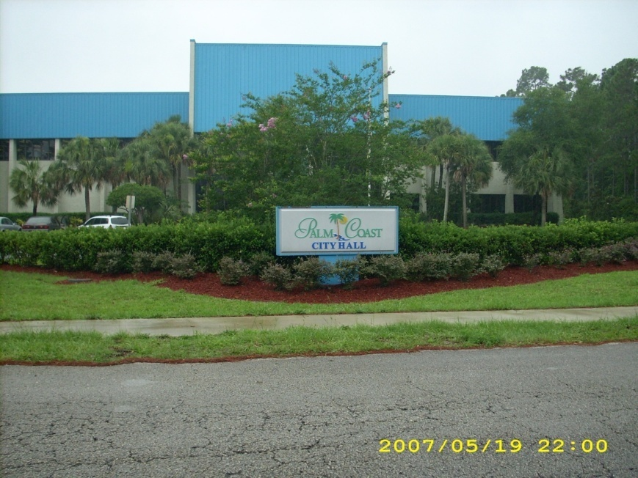
By:
Thomas J. Schmokel - ADA Consultant / Professional Accessibility Consultant
2641 Chateau Lane, Suite # C
Tallahassee, Florida 32311
(850) 942-5505
Thomas@Schmokel.com
www.americans-with-disabilities-act.com
Property Inspections performed on February 20th 2007 and thereafter.
Report Delivery June 26, 2007
Inspections performed by Tom Schmokel, and attended by Pamela Barrett – HR Director, ADA Coordinator, and Fran Martin – formerly of Public Works. The group visited and inspected for accessibility barriers, all improved city controlled properties and parks to identify physical barriers to accessibility. These barriers are listed below with narrative, and upon the accompanying spreadsheet, listed by property, ADAAG / FACBC section number violation, and associated retrofit costs per the Means ADA Compliance Pricing Guide 1994 and/or The New ADA: Compliance and Costs by Kearney, and/or personal research & experience: when available.
Introduction
The City of Palm Coast is considered an ADA Title II entity and is pursuant to Regulations promulgated by the United States Department of Justice, the city is mandated to;
a) identify a responsible party as “ADA coordinator”
b) provide accessibility to all “programs, services, and activities…” (Hereinafter PSA’s) under ADA Title II (not necessarily to all facilities): though under ADA Title I, and the Rehab Act of 1973 as amended, public facilities must also be accessible for employment purposes.
c) perform an “ADA self-assessment…” and to prepare a transition plan towards achieving full ADA access for all public city functions. The transition plan must address all identified barriers to accessibility from this report, and provide a reasonable timeline for the removal of said barriers of both an architectural and/or communication barrier nature. This is made easy using the last column in the spreadsheet for anticipated completion dates.
Further the city has ADA Title I responsibilities to provide covered employees and applicants with reasonable accommodations upon written request, within a timely manner, and to identify the person(s) responsible and to whom, and in what manner such requests must be made. i.e. Persons with hearing/speech impairments requesting a translator for assistance in addressing a City Council Meeting must request such accommodation 72 hours in advance of the beginning of the meeting from Pamela Barrett – City of Palm Coast - Human Resources Director / ADA Coordinator. All Written complaints and correspondence regarding the City of Palm Coast’s Accessibility by policy are to be addressed to: Pamela Barrett – City of Palm Coast - Human Resources Director / ADA Coordinator.
- Web Site Accessibility: Section 508
Under the Section 508 of the Rehabilitation Act, internet web sites of governmental agencies must be made accessible to persons with visual and communication disabilities. CompUSA in Tallahassee offers courses for internet personnel teaching all of the necessary and mandatory practices towards achieving this goal. I recommend sending your webmaster to one of this specialty two day training courses. Budget cost is $800 per person.
Info available at:
http://www.compusa.com/training/overview/Web_Site_Accessibility.asp

- Utilities Administration
- Utility Drive
- Very steep ramp at curb, replace 6 feet of concrete with sloped concrete ramp. Est. Cost $400
- 4 conference rooms lack visual strobe alarms. Install Est. Cost is $371.00 each
- Front Entry Doors (bullet proof/ resistant) clear opening less than 32”, opening force 30#.
- Provide pneumatic door openers set to simultaneously open both exterior doors to create a 32” + opening. Install dual door automatic opener with interior & exterior actuator switches Est. Cost $6,500.00
- Replace 2 existing antiquated inaccessible drinking fountains /water coolers with accessible drinking fountains with a Hi/Lo configuration. Est. Cost each is $2,216.00 Total for (2) $4,432
- Add Braille Signs where permanent room signs are provided. To add Braille room number signs on 6 doors (restrooms & conference rooms) cost is approximately $200.

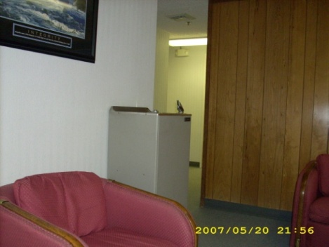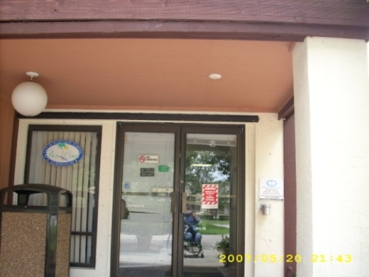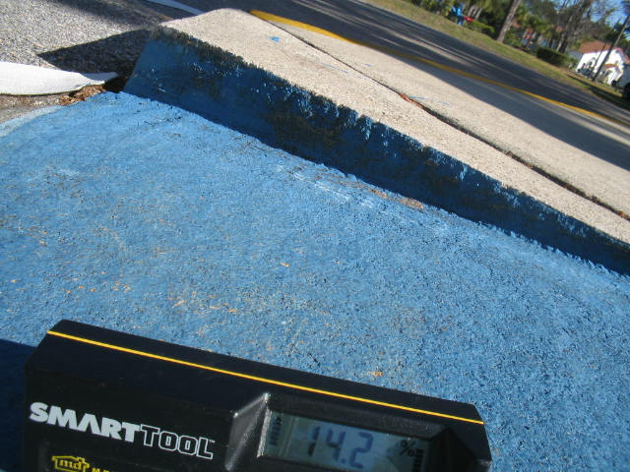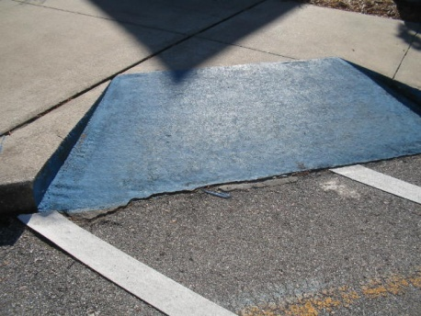

- Community Center
305 Palm Coast Parkway
- Add Braille Signs where permanent room signs are provided. To add Braille room number signs on 12 doors cost is approximately $350.

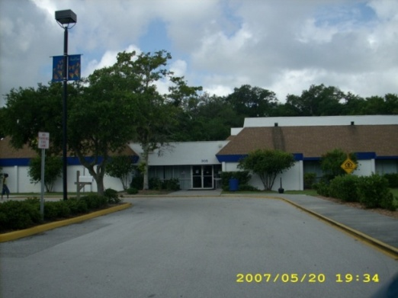
- Create a single unisex restroom within the existing two restroom footprint: this will necessitate refurbishing both restroom facilities partially to better utilize the existing space. Estimated cost is $35,000. This project will take an architect and contractor to determine best placement.
- Install TDD or TTY at Reception area in Community Center along with Signage announcing availability at this location. Ameritech Printing TDD, $600, Sign $50, wiring $150… Total $800
- Install new Drinking Fountain with Hi/lo configuration. Est. Cost each is $2,216.00
- Visual Alarms lacking in (3) conference rooms (102, 107. & 108) ADAAG 4.28
Install Visual Strobe Alarm in Conference Room Est. Cost $288 X (3).
- Install Braille Signs on all 4 Conference Room Entry Doors.
- Replace inaccessible doorknobs in all conference rooms with accessible levered door hardware.
- Add assistive listening system in 102 Williams Sound Assistive Listening System $900
http://www.bhphotovideo.com/bnh/controller/home?A=details&kw=WIPPA37500H&is=REG&Q=&O=productlist&sku=498398
Also add signage indicating availability see ADAAG Fig. 43
- The Community Center lacks any accessible playground and should install a 4-5 accessible station play structure relatively close to the building and connect to building network with a paved sidewalk. This will cost an estimated $25,000

- City Hall
2 Commerce Blvd.
- Television in City Manager’s Office is wall hung without 80” of clearance beneath making it an overhead protruding object. Permanently place something (i.e. potted plant or trash receptacle) beneath this television which is at least 27” tall to act as a cane detection barrier for the visually impaired. (see ADAAG 4.4 Fig. 8: overhead protruding object0
- Add Braille Signs where permanent room signs are provided. To add Braille room number signs on 24 doors cost is approximately $650.
- Provide folding shelves 36” height X 36” Width X 18” width, at counters where people must sign documents. (1) at reception desk, (1) building inspection payment desk, (1) permitting
Using folding shelf hinges (link below) and 18’ X 36” board. Folding Shelf Hinge info link follows; http://www.hardwaresource.com/Store_ViewCatLevel3.asp?Cat=19 Est. Cost per unit is $89 X (3)
http://www.rockler.com/product.cfm?page=10227&cookietest=1 link to another bracket
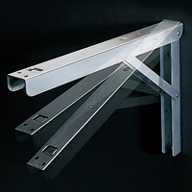
- Rebuilding the ground floor restrooms into; a mens, ladies, and unisex / accessible restroom can be accomplished with the attached configuration sketch. Doing so will alleviate the need to provide any other accessible restroom facilities on this floor. This project will cost an estimated $58,000.
- Find new location to install a new Hi/Lo configuration Drinking Fountain on the ground floor.
This is entirely dependent upon available plumbing. Estimated cost $2,281.
- The upstairs restroom set on the lower level of the second floor have 29” wide door clearances which need to be replaced. The 3’ X 5’ inaccessible stalls, and inaccessible lavatories will have to be re-partitioned and replaced respectively. These restrooms will also need complete reconstruction into either accessible men’s and accessible ladies, or an additional unisex accessible restroom where the Janitor’s closet is presently situated. Estimated cost to entire retrofit is $42,000 and should fully comply with both ADA & FACBC regulations. There is presently no accessibility within these restrooms. We looked at the possibility of expanding the City Manager’s restroom into an accessible unisex restroom: but concluded the expense would exceed the cost of building a new accessible unisex superimposed over the janitor’s closet, due to the much higher level of décor.
- Install vertical lift for to access the second floor break room, conference room and restrooms. Savaria Porch Lift Estimated Cost for 37” rise is $8,500.00
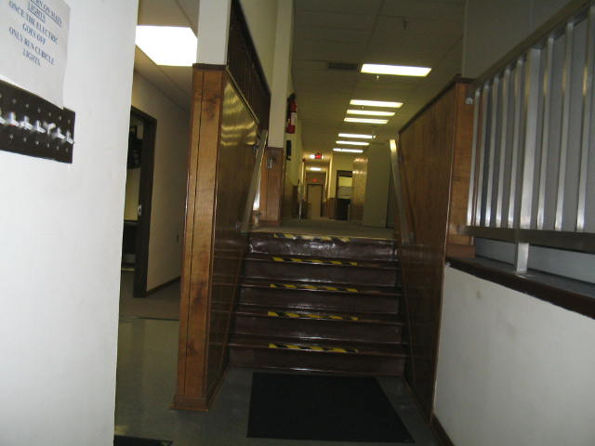
Contact:
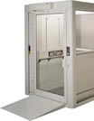 | Dawn Connor  Daytona Elevator  440 Spring Forest Dr.  New Smyrna Beach, Florida 32168  Phone: 386/423-7226 Fax: 386/427-4763  Email: info@daytonaelevator.com  Website:www.daytonaelevator.com

- Repartition stalls in both the Mens and Ladies Restrooms to provide mandatory clearances within an accessible stall. It is quite likely that losing one fixture per restroom will be necessary (on both first and second floors). $11,200 per Restroom X 2 = $22,400
- Install TDD or TTY at Reception area in City Hall and at Community Center along with Signage announcing availability at this location. Super-Print TDD, $600, Sign $50, wiring $150… Total $800
- Replace/Add Levered Door Handles on Conference Room Doors (2) $150 each (2) $300
- Install Visual Strobe Alarm in Conference Room (2nd floor) Est. Cost $288
- Employee parking needs to be restriped and proper parking signs per FACBC. $249 for (2)
- Replace doorknob on employee entrance door,
- adjust odor closer to 8# opening force, if not adjustable: replace closer.

- Public Works
- Add Braille signs on Restrooms
- Public Works is used as a Citizen’s Academy Training Station, which necessitates accessible toilet facilities, a connecting route, and accessible parking. ($1200), and the following restroom modifications at a total cost of $$3,500.

- If you purchase an Accessible Trailer Restroom and set it by the Facility Management Workshop for these functions, you can eliminate adding the following: a 50’ section of 36” wide sidewalk to connect the two buildings
- Remove partitions in both men’s and ladies restrooms to provide mandatory floor clearances at toilet fixtures.
- Install grab bars 36” behind, and 42” beside existing toilets.
- Remove existing cabinet & lav’s and install new wall mounted accessible lav’s with levered faucet handles, and insulation around drain and supply tubes.
- Add Braille signage on both restrooms.
- Add levered door handle bathroom sets. Lower mirrors to 40” max height or lower. See ADAAG 4.19 Figs. 30, 31, & 32
- Install handicap height toilets,
- Install a folding shelf 36” wide by 18” near main reception counter at 36” height.
Use a set of folding shelf hinges (link below) and 18’ X 36” board.
http://www.hardwaresource.com/Store_ViewCatLevel3.asp?Cat=19
- At Facility Maintenance Workshop pour a concrete slab for handicap parking space 18’ X 15’
Stripe with markings per Florida Parking Diagram.
- Replace door knobs on front, rear, and workshop doors with levered door sets (3) @ $200 each.
- Connect workshop & main buildings with asphalt sidewalk, concrete is too brittle under the weight of the public works trucks. $1,200

- Fire Stations
Main Fire Station #21
4751 Belle Terre Pkwy
Accessible Parking and accessible route into building is excellent, the only problem noted here is that restrooms were built in the 1980’s and handicap stalls don’t comply with ADA. It may be possible to repartition, however, doing so starts a domino effect of exorbitant costs, and the likely loss of toilet fixtures. Since loss of toilet fixtures is unacceptable: I recommend buying ADA Restroom Trailers.
Fire Station #22
309 Palm Coast Parkway
The entrances have narrow doorways (less than 32” clear) and a vertical rise of 1 1/2 ‘.
The restroom doors are around 22” width and completely inaccessible. Since this building is completely outdated: costly retrofits are not recommended. Rather I recommend installing a Drive-Up Big Bell from Inclusion Solutions.com http://www.inclusionsolutions.com/bigbell.htm for people with disabilities to signal emergency personnel to have their blood pressure taken in the car.
- Big Bell Cost per station $250 includes S&H, and installation & your signage. Est. Cost for (3) $750
- ADA Restroom Trailer cost per station $27,000: each usable in multiple situations, I recommend purchasing one for each fire station. Then utilizing for all citizens academy functions and all other major public functions.
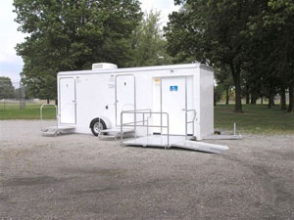
To provide accessible restroom facilities at the Fire Stations, I recommend the city purchasing portable ADA Restroom Trailers http://www.wellscargocog.com/ada_units.html for each of the 3 Fire Stations. Final total cost of providing 3 such trailers will be around $90,000 delivered and set-up. These trailers could be utilized at all public functions and thereby provide excellent access provision by the city. Contact name at Wells Cargo COG is Tim @ 888-574-4222 and ask him for the “Tom Schmokel” Discount, as I helped design these units.
Fire Station #23
5750 Belle Terre Pkwy 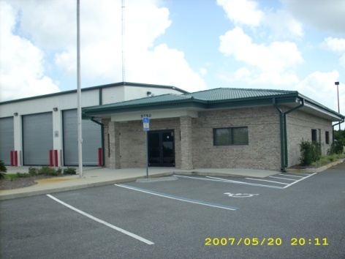
Parking & Accessible route into building is excellent. Restrooms not fully ADA Accessible, replace vanity in Ladies Restroom with wall mounted accessible sink, insulate drain & supply lines. Est. Cost is $529
- Main entry door has un-beveled door threshold, either bevel existing by grinding or replace with new. Est. Cost is $79

- Water Treatment Filter Facility
50 Citation Rd
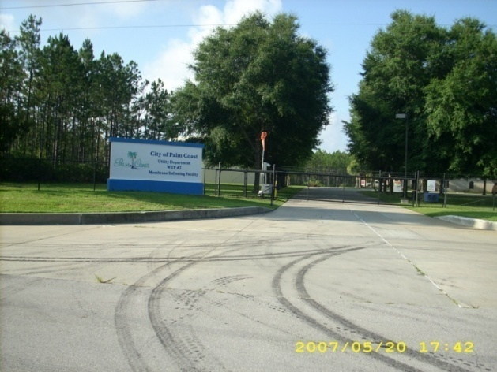
This facility lacks handicap restroom facilities on the ground floor. The restroom facilities are located on the second floor and also lack complete accessibility. This is a Citizen’s Academy Training Facility making a restroom a necessity: I recommend either
- installing a lift to the second floor and modifying the restrooms: or
- b) An excellent solution would be utilizing one of the ADA Restroom trailers I’m recommending purchasing for the Fire Stations at this location: would pay for 1 of the Restroom Trailers , while meeting ADA requirements.
- It is also necessary to re-stripe the existing accessible parking spaces and providing new signs and posts per the Florida Parking requirements sheet attached.
The cost of installing a lift to the second floor of this facility is estimated at $21,000 due to the 14’ height of necessary lift. Contact Daytona Elevator for an exact quote, installed.
Dawn Connor
Daytona Elevator
440 Spring Forest Dr.
New Smyrna Beach, Florida 32168
Phone: 386/423-7226 Fax: 386/427-4763
Email: info@daytonaelevator.com
Website:www.daytonaelevator.com

- Water Treatment Plant
- Install an accessible paved parking space 12’ wide with adjacent 5’ access aisle. Paint sign & post cost an estimated $160
- Accessible restroom, lacking only a single grab bar behind toilet 36” and a Braille sign on wall adjacent to the latch side of the restroom door. Estimated cost for both items installed is $139.

- Fred Zambia Pool
4510 Belle Terre Parkway
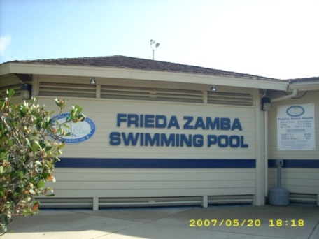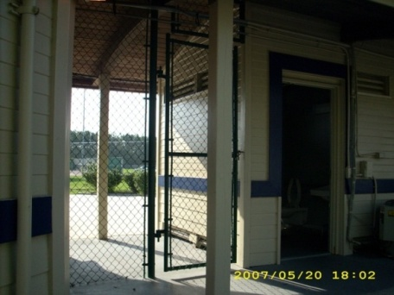
- Fred Zambia Pool lacks any handicap parking what-so-ever and should have at least one or two spaces installed 12’ wide plus a 5’ wide access aisle.
- The showers in the locker rooms have an 8” curb and would be difficult to make fully accessible. The shower lacks an adjustable height showerhead with 60” hose. There is a roofed area between the handicap accessible restrooms and Office which could easily be enclosed, plumbed, mudded, and tiled, to construct an accessible shower/locker area for persons with disabilities. Estimated cost is $7,500 total including folding shower bench, grab bars, cabinets or lockers, and a 24” X 48” changing bench. This project would be less expensive than retrofitting both mens and ladies locker rooms.

- The Fred Zambia Pool does exceed the ADA in that you already have pool lifts installed to provide access into the pool.

- Install new Drinking Fountain with Hi/lo configuration. (or make paper cups available for people with disabilities at concession stand upon request and provide signage to this effect). Est. Cost each is $2,216.00
- Holland Park
18 Florida Park Drive

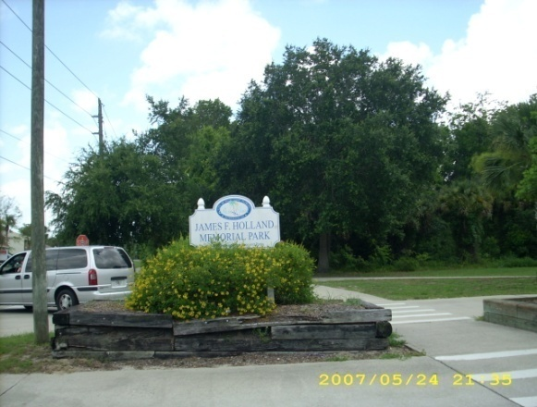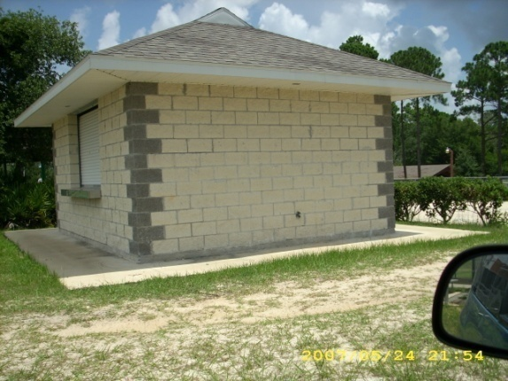

Holland Park is the oldest of the City Parks, and accessibility is extremely limited due to lack of connecting sidewalks. I strongly urge the City to repair existing sidewalks and connect all functions and activities to accessible parking.
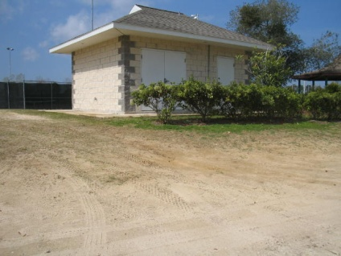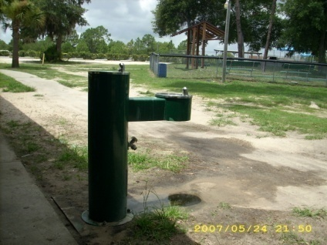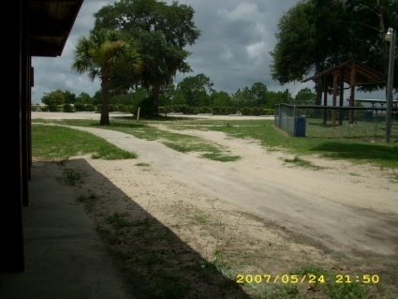
- There is a ramp up to the Gazebo which could very easily connect to the Concession Stand with an addition of appx.20 feet of concrete sidewalk. There is no fully paved route connecting disabled parking to restrooms, the concession stand, the multiple picnic shelters and playground activities. I estimate that between 1,000 feet of sidewalks or concrete walkways 48” wide could accomplish near full access at a cost of $20 per linear ft. Grade the areas demarcated for these accessible sidewalks such that the slopes are less than 1:20, or less than ADA ramp slopes, and handrails are not required along these routes which are not considered ramps. Cost $20,000

- The restrooms in the concrete shelter are fully ADA accessible lacking only signage indicating this fact. The sidewalks connecting are washed out in areas and submerged in dirt in other sections. There are no accessible playground sections at this location. I recommend installing a fully accessible playground with 6-8 activities all accessible between the two restroom buildings, and connecting sidewalks to both facilities. These measures will greatly enhance access at this park. Estimated cost for an Accessible Playground project is $25,000 and another $20,000 for the additional necessary sidewalks.

- There is sand and dirt on many of the paved routes which presents a barrier to access for people with disabilities. More frequent maintenance of these routes is vital. The drinking fountain is not on a paved route with a proper 60” X 60” pad. Reinstallation is recommended at a more suitable location which will allow for dryer conditions. (included in sidewalk costs)
- The newly constructed classroom is perfect with the exception of one improperly mounted grab bar in the restroom, and no Braille Sign on the Restroom should be mounted at 60” to centerline on the wall, on latch side of the door. The handicap parking spaces also need proper signage mounted at 84” to bottom edge of sign. Handicap parking is provided though it lacks appropriate signage and posts. (included in sidewalk costs)
- The outdoor Drinking Fountains lack a solid ground surface (concrete pad 60” X 60”) and they are not properly installed on accessible routes. Drinking Fountain spout heights are also well below proper accessible height of 30”. They should be reinstalled in accessible locations. (included in sidewalk costs)
- All six disabled parking spaces need new 10’ posts to mount the signs per ADAAG at 84” to bottom of sign. Repainting the lines and access aisles should be done at least biannually.
- City Parks & Recreation
The new parks are nearly ideal models for accessible construction: and were obviously well researched by parks personnel.
- Hero’s Park
Palm Coast Parkway @ Corporate Drive N (fully accessible)
- Indian Trails
Park Belle Terre Parkway
2 restrooms (fully accessible)
- Baseball Refreshment Stand
5455 Belle Terre Parkway (fully accessible) excepting grate on accessible route pic IMG_0657.JPG which needs to be replaced due to openings more than ¾” perpendicular to the route of travel, in to which crutches, canes, and wheelchair wheels could fall.
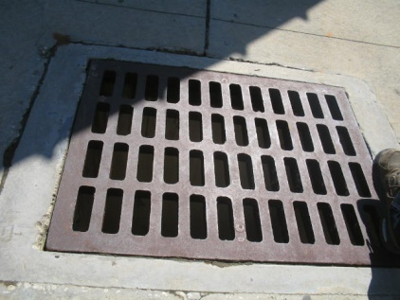
- Refreshment Stand
18 Florida Park Drive (not even on accessible route at Holland Park)
- Linear Park
31 Green Way Court (fully accessible)

- Fred Zambia Pool
4510 Belle Terre Parkway
- Fred Zambia Pool lacks any handicap parking what-so-ever and should have at least two spaces installed 12’ wide sharing a 5’ wide access aisle.
- The showers in the locker rooms have an 8” curb and would be difficult to make fully accessible. The shower lacks an adjustable height showerhead with 60” hose. There is a roofed area between the handicap accessible restrooms and Office which could easily be enclosed, plumbed, mudded, and tiled, to construct an accessible shower/locker area for persons with disabilities. Estimated cost is $8,500 total including folding shower bench, grab bars, cabinets or lockers, and a 24” X 48” changing bench. This project would be less expensive than retrofitting both mens and ladies locker rooms.

- Install new Drinking Fountain with Hi/lo configuration. (or make paper cups available for people with disabilities at concession stand upon request and provide signage to this effect). Est. Cost each is $2,216.00

- The Fred Zambia Pool does exceed the ADA in that you already have pool lifts installed to provide access into the pool.

- Accommodation Fund
I recommend creating an annually refunded “Accommodation Fund” in the amount of $20,000 to provide accommodations and retrofits which are requested by the public, such as interpreters for the deaf for attending public meetings, and for employment accommodations in case someone with a disability applies for employment with the city.
CONCLUSIONS
The City of Palm Coast will need to budget an estimated $300,000 for ADA Retrofits citywide, due to the age of their existing facilities and lack of accessibility in certain areas. Most if not all of these are inherited problems that came with the purchase of the old buildings and facilities upon incorporation of the city.
Top priority should be given to the restroom and vertical access problems at City Hall, the inaccessible restroom problems at the Community Center, and all Citizen Academy training locations (City Hall, Public Works, Community Center, Water Treatment Filtration Facility, Main Fire Station, and Utility Administration Building) and finally to providing an accessible shower facility at the Fred Zambia Pool.
Purchasing three ADA Restroom Trailers for $30,000 each could save an estimated $100K-$120K in overall costs for rebuilding restrooms in outdated and infrequently utilized public facilities.
When adding and/or restriping existing accessible parking spaces within the State of Florida,
The following configuration must be utilized:

Florida Parking Requirements.
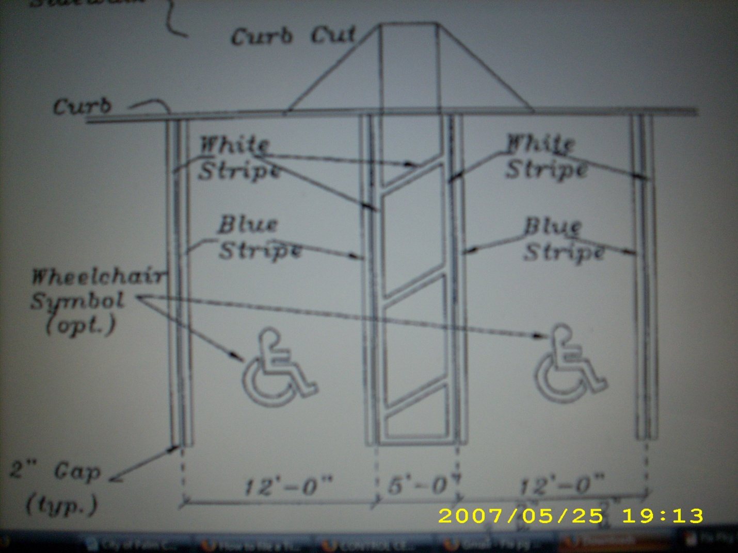
Parking Signs must be mounted at 84” height to bottom of sign, $250 Violation Tag Signs are also mandatory per Florida Statutes.
Accessible Playground Manufacturers
KORKAT INC.
221 Cable Industrial Way
Carrolton, GA 30117 USA
Ph: (888) 356-7528 / (770) 214s-9322|
Fx: (770) 214-9323

PLANET PLAYGROUNDS
1925 Shiloh Road, Bldg. 1
Kennesaw, GA 30144 USA
Ph: (800) 661-7295 / (770) 792-9300
Landscape Structures Inc.
PO Box 198
601 7th Street South
Delano, MN 55328-0198
1-888-438-6574
http://www.playlsi.com

