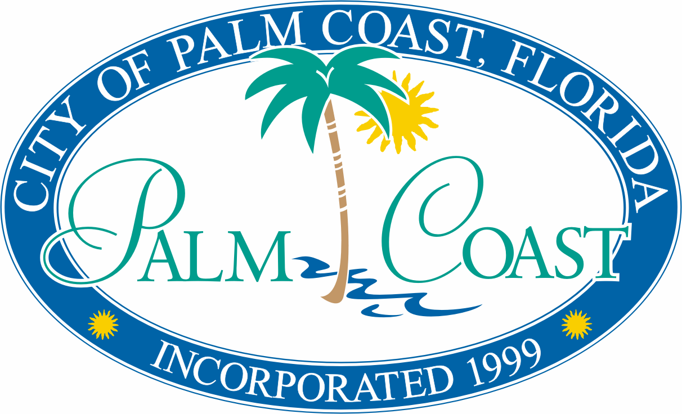

**AGREEMENT**

**THIS AGREEMENT** is made and entered into this ___ day of ____________________, 2017, by and between the CITY OF PALM COAST, a Florida municipal corporation, whose address is 160 Lake Avenue, Palm Coast, Florida, 32164, hereinafter referred to as “CITY,” and the City of Palm Coast Historical Society and Museum, Inc., whose address is 18 Florida Park Drive, Palm Coast, FL 32137, a Florida Non Profit Corporation, hereinafter referred to as “Historical Society” together hereinafter referred to collectively as “Parties.”

***WITNESSETH:***

**WHEREAS,** the HISTORICAL SOCIETY operates as the source for information and documentation on the history of City; and

**WHEREAS,** the HISTORICAL SOCIETY provides services and other public benefits for the citizens of CITY; and

**WHEREAS**, the HISTORICAL SOCIETY, through the use of real property provided and funds invested by the CITY, will provide those services and other public benefits for the citizens of CITY as set forth herein, and

**WHEREAS,** theCITY has concluded that the use of real property and the investment of public funds in the HISTORICAL SOCIETY in the amount set forth herein is in the public interest and the City Council of the CITY has concluded that the services and benefits, as set forth herein, are in the public interest and provide for and accomplish a public purpose; and

**WHEREAS,** the City Council of the CITY has found and determined that the provisions of this Agreement are consistent with all applicable law and implement the provisions of controlling legal authority.

**NOW, THEREFORE,** in consideration of the terms, provisions and covenants contained herein, the Parties hereto do mutually agree as follows:

**SECTION 1. RECITALS.** The foregoing recitals are true and correct and form a material part of this Agreement upon which the Parties have relied.

**SECTION 2. LENGTH OF AGREEMENT.** This Agreement shall be effective on the date of the complete execution hereof by the Parties and shall continue in effect until September 30, 2018. This Agreement may be renewed by the City with sixty (60) days written notice for two additional one-year terms, subject to the express terms herein, upon the approval of City Council’s fiscal budget and dependent upon City Council appropriation of funding of its contribution. Nothing herein may be construed to be or constitute a binding obligation on the City to extend this Agreement.

**SECTION 3. PURPOSE.** Subject to the terms and conditions hereinafter set forth, HISTORICAL SOCIETY shall provide the services as set forth in Section 4 of this Agreement and the CITY shall provide funding and use of real property as set forth in Section 5 of this Agreement.

**SECTION 4. SERVICES PROVIDED BY THE HISTORICAL SOCIETY**

(A) The HISTORICAL SOCIETY will provide services for the CITY by providing the public and the citizens of the CITY with information regarding the history of the Palm Coast community prior to the CITY’s incorporation as well as historical information regarding the CITY after its incorporation, including but not limited to, the preservation of this historical information and documents.

(B) The services that the HISTORICAL SOCIETY shall provide to the CITY under the terms and conditions of this Agreement shall occur or be located within the City Limits of the CITY.

(C) The HISTORICAL SOCIETY shall acknowledge and recognize, in writing and in all marketing materials, which may or may not utilize the official City logo, the City of Palm Coast for support of their services. Procurement and utilization of the official City logo must follow established guidelines. All materials with this acknowledgement and recognition of support must be submitted to the Parks & Recreation Department for record keeping purposes.

**SECTION 5. PROVISION OF FUNDS AND USE OF REAL PROPERTY.** In consideration for the services described in Section 4, the CITY shall provide the following:

* 1. The sum of three thousand dollars ($3,000.00) for the fiscal year ending September 30, 2017 for operational expenses.
  2. The use of Activity Rooms A and B within Holland Park, at 18 Florida Park Drive, Palm Coast, Florida 32137 (hereinafter “Real Property”) for the term of this Agreement.Such use shall be subject to the CITY’s right to access as needed.
  3. The CITY will provide basic janitorial services for the Real Property a maximum of two times a week.

**SECTION 6. ACCESS TO RECORDS/AUDIT/PUBLIC RECORDS.**

(A) The Parties specifically acknowledge that this Agreement is subject to the laws of the state of Florida, including without limitation Chapter 119, Florida Statutes, which generally make public all records or other writings made or received by the Parties. If HISTORICAL SOCIETY is either a “Contractor” as defined in Section 119.0701(1)(a), Florida Statutes, or an “agency” as defined in Section 119.011(2), Florida Statutes, HISTORICAL SOCIETY shall:

1. Keep and maintain all public records required by the CITY to perform the services herein; and
2. Upon request from the CITY’s custodian of public records, provide the CITY with a copy of the requested records or allow the records to be inspected or copied within a reasonable time at a cost that does not exceed the cost provided in Chapter 119, Florida Statutes or as otherwise provided by law; and
3. Ensure that public records that are exempt or confidential and exempt from public records disclosure requirements are not disclosed except as authorized by law for the duration of the Agreement Term and following completion of the Agreement if HISTORICAL SOCIETY does not transfer the records to the CITY; and
4. Upon completion of the Agreement, transfer, at no cost, to the CITY all public records in possession of the HISTORICAL SOCIETY or keep and maintain public records required by the CITY to perform the services herein. If the HISTORICAL SOCIETY transfers all public records to the CITY upon completion of the Agreement, the HISTORICAL SOCIETY shall destroy any duplicate public records that are exempt or confidential and exempt from public records disclosure requirements. If the HISTORICAL SOCIETY keeps and maintains public records upon completion of the Agreement, the HISTORICAL SOCIETY shall meet all applicable requirements for retaining public records. All records stored electronically must be provided to the CITY, upon request from the CITY’s custodian of public records, in a format compatible with the information technology systems of the CITY.

(B) All requests to inspect or copy public records relating to the Agreement shall be made directly to the CITY. Notwithstanding any other provision of this Agreement to the contrary, failure to comply with the requirements of this paragraph shall result in the immediate termination of the Agreement, without penalty to the CITY. A HISTORICAL SOCIETY who fails to provide the public records to the CITY within a reasonable time may be subject to penalties pursuant to Section 119.10, Florida Statutes. Further, the HISTORICAL SOCIETY shall fully indemnify and hold harmless the CITY, its officers, agents and employees from any liability and/or damages, including attorney’s fees through any appeals, resulting from the HISTORICAL SOCIETY’s failure to comply with these requirements.

(C) **IF THE HISTORICAL SOCIETY HAS QUESTIONS REGARDING THE APPLICATION OF CHAPTER 119, FLORIDA STATUTES, TO THE HISTORICAL SOCIETY’S DUTY TO PROVIDE PUBLIC RECORDS RELATING TO THIS AGREEMENT, CONTACT THE CITY’S CUSTODIAN OF PUBLIC RECORDS, ATTN: VIRGINIA SMITH, CITY CLERK, AT 386-986-3713, vsmith@palmcoastgov .com, 160 LAKE AVENUE, PALM COAST, FLORIDA 32164.**

(D) The HISTORICAL SOCIETY agrees that if any litigation, claim, or audit is started before the expiration of the record retention period established above, the records shall be retained until all litigation, claims, or audit findings involving the records have been resolved and final action taken.

**SECTION 7. DISCLAIMER OF THIRD PARTY BENEFICIARIES.** This Agreement is solely for the benefit of the formal Parties herein, and no right or case of action shall accrue upon or by reason hereon, to or for the benefit of any third party not a formal party hereto.

**Section 8. Indemnification.**

(A) HISTORICAL SOCIETY shall indemnify, hold harmless, and defend the CITY, from and against any and all claims, damages, losses, and expenses including, but not limited to, attorney’s fees, arising out of or resulting from the performance or provision for services required under this Agreement, including damage to persons or property, provided that same is caused in whole or part by the error, omission, negligent act, failure to act, malfeasance, misfeasance, conduct, or misconduct of HISTORICAL SOCIETY, its agents, servants, officers, officials, employees, or subcontractors.

(B) Nothing herein shall be deemed to affect the rights, privileges, and immunities of the CITY as set forth in Section 768.28, Florida Statutes.

(C) In claims against any person or entity indemnified under this Section by an employee of the HISTORICAL SOCIETY or its agents or subcontractors, anyone directly or indirectly employed by them or anyone for whose acts they may be liable, the indemnification obligation under this Section shall not be limited by a limitation on amount or type of damages, compensation, or benefits payable by or for the HISTORICAL SOCIETY or its agents or subcontractors, under Workers Compensation acts, disability benefits acts, or other employee benefit acts.

(D) The execution of this Agreement by the HISTORICAL SOCIETY shall obligate the HISTORICAL SOCIETY to comply with the indemnification provision in this Agreement, however, the HISTORICAL SOCIETY must also comply with the provisions of this Agreement relating to insurance coverages.

**SECTION 9. INSURANCE.** During the term of this Agreement**,** including any renewal periods, the HISTORICAL SOCIETY shall be responsible for providing insurance covering the contents and any personal property that the HISTORICAL SOCIETY places or maintains in the Real Property. Further, during the term of this Agreement, including any renewal periods, the HISTORICAL SOCIETY shall obtain, provide and maintain property and general liability coverage for its use of the Real Property and coverage for risks identified in Section 8, Liability in the amount of $1,000,000 per occurrence and $2,000,000 general aggregate. Said insurance policy shall provide that the CITY is an additional named insured on the liability coverage and loss payee on the property coverage. The HISTORICAL SOCIETY shall provide a copy of the current insurance policy upon the effective date of this Agreement and thereafter, upon the request of the CITY.

**SECTION 10. ASSIGNMENT.** This Agreement shall be binding on the Parties hereto and their representatives and successors. Neither party shall assign this Agreement or the rights and obligation to any other party.

**SECTION 11. DEFAULT**.

(A) In the event of default by the HISTORICAL SOCIETY, the CITY shall be entitled to any and all legal remedies available under Florida law.

(B) Each of the Parties hereto shall give the other party written notice of any defaults hereunder and shall allow the defaulting party thirty (30) days from the date of receipt to cure such defaults.

**SECTION 12. NOTICES**. Any notice required or allowed to be delivered hereunder shall be in writing and be deemed to be delivered when either (1) hand delivered to the official hereinafter designated, or (2) upon receipt of such notice when deposited in the United States mail, postage prepaid, certified mail, return receipt requested, addressed to a party at the address set forth opposite the party’s name below, or at such other address as the party’s name below, or at such other address as the party shall specify by written notice to the other party delivered in accordance herewith.

**HISTORICAL SOCIETY:** The City of Palm Coast Historical Society and Museum

Attn: President

18 Florida Park Drive

Palm Coast, FL 32137

**CITY:** City of Palm Coast

Attn. City Manager

160 Lake Avenue

Palm Coast, Florida 32164

**With a copy to:** City of Palm Coast

Attn: Risk Management & Contract Coordinator

160 Lake Avenue

Palm Coast, Florida 32164

**SECTION 13. SEVERABILITY.** If any part of this Agreement is found invalid or unenforceable by any court, such invalidity or unenforceability shall not affect the other parts of the Agreement if the rights and obligations of the Parties contained therein are not materially prejudiced and if the intentions of the Parties can continue to be affected. To that end, the terms of this Agreement are declared severable.

**SECTION 14. TERMINATION.** This Agreement may be terminated at any time by either party upon thirty (30) days’ written notice to the other party. All terms that by their nature should survive the termination or expiration of this Agreement shall survive including, but not limited to, Sections 6, 7, 8, 11,13, 15, 16, 20, 23, 24, and 25. Any monies provided to HISTORICAL CITY, not used in accordance with this Agreement prior to the effective date of termination shall be refunded to the CITY.

**SECTION 15. APPLICABLE LAW/VENUE.** This Agreement and the provisions contained herein shall be construed, controlled, and interpreted according to the laws of the State of Florida. Venue for any legal proceeding related to this Agreement shall be in the Seventh Judicial Circuit Court in and for Flagler County, Florida.

**SECTION 16. ATTORNEYS FEES.** In the event it becomes necessary to institute legal action to enforce any of the terms of this Agreement, the prevailing party shall be entitled to recover all out-of-pocket expenses and costs and all reasonable attorneys’ fees, paralegal fees and associated fees and costs from the date of filing until the termination of litigation whether incurred at trial, on appeal, or otherwise.

**SECTION 17. EFFECTIVE DATE.** This Agreement shall take effect when adopted by CITY and HISTORICAL SOCIETY, and fully executed by their duly authorized representatives.

**SECTION 18. NONDISCRIMINATION.** The HISTORICAL SOCIETY agrees that it will not discriminate against any employee or applicant for employment for work under this Agreement because of race, color, religion, sex, age, national origin or disability and will take affirmative steps to insure that applicants are employed and employees are treated during employment without regard to race, color, religion, sex, age, national origin or disability. This provision shall include, but not be limited to, the following: employment, upgrading, demotion or transfer; recruitment advertising; layoff or termination; rates of pay or their forms or compensation; and selection for training, including apprenticeship. The HISTORICAL SOCIETY, moreover, shall comply with all the requirements as imposed by the *Americans with Disability Act*, the regulations of the Federal government issued thereunder, and any and all requirements of State law related thereto.

**SECTION 19. FURTHER DOCUMENTS.** Each of the Parties hereto hereby agree that they will execute and deliver such further instruments and do such further acts and things as may be necessary or desirable to carry out the purpose of this Agreement.

**SECTION 20. FAILURE TO ENFORCE NOT WAIVER OF RIGHT**. Failure by City to enforce any provision contained herein shall not be deemed a waiver of the right to do so thereafter as to the same breach or as to any breach occurring prior or subsequent thereto.

**SECTION 21. FORCE MAJEURE.** The CITY’s obligations hereunder shall be subject to the concept of *force majeure*. Accordingly, in the event of Acts of God, riot, weather disturbances, permitting, war, terrorism, civil disobedience, geologic subsidence, electrical failure, malfunctions, and events of a similar nature, the CITY shall be excused from providing continual utility service until the cause or causes thereof have been remedied.

**SECTION 22. HEADINGS/CAPTIONS.** Section headings and other captions contained in this Agreement are for reference purposes only and are in no way intended to describe, interpret, define, or limit the scope, extent or intent of this Agreement, or any provision hereto.

**SECTION 23. INTERPRETATION.** The CITY and the HISTORICAL SOCIETY agree that all words, terms and conditions contained herein are to be read in concert, each with the other, and that a provision contained under one (1) heading may be considered to be equally applicable under another in the interpretation of this Agreement. This Agreement shall not be construed more strictly against either party on the basis of being the drafter thereof, and both Parties have contributed to the drafting of this Agreement.

**SECTION 24. COUNTERPARTS.** This Agreement may be executed in any number of counterparts, each of which shall be deemed an original, but all of which, taken together, shall constitute one (1) and the same document.

**SECTION 25. ENTIRE AGREEMENT.** This instrument constitutes the entire agreement between the Parties and supersedes all previous discussions, understandings, and agreements between Parties relating to the subject matter of this Agreement. This Agreement may not be amended, changed, or modified, and material provisions hereunder may not be waived, except by a written document, of equal dignity herewith, approved by the City Council of the CITY and the HISTORICAL SOCIETY and executed by all Parties to this Agreement in a formal Amendment.

**IN WITNESS WHEREOF,** the Parties hereto have hereunder executed this Agreement in the date and year first above written.

**City of Palm Coast Historical Society CITY OF PALM COAST**

**and Museum, Inc.**

By: __________________________ By: ___________________________

Jim Landon, City Manager

Print: ________________________

Title: _________________________ Date: _________________________

Date: ________________________