EXHIBIT “B”

PALM HARBOR SHOPPING CENTER
MASTER PLANNED DEVELOPMENT AGREEMENT
Prepared by:
First and Last Name
Address
City, State, zip code
Return to:
City Clerk
City Hall
160 Cypress Point Parkway, Suite B-106
Palm Coast, FL 32164

------------------- | [SPACE ABOVE THIS LINE FOR RECORDING DATA] | --------------------

MASTER PLAN DEVELOPMENT AGREEMENT BETWEEN THE CITY OF PALM COAST AND PALM HARBOR CENTER ASSOCIATES, A FLORIDA GENERAL PARTNERSHIP AND IW OF PALM COAST, LP.
THIS MASTER PLAN DEVELOPMENT AGREEMENT, (herein referred to as the “Development Agreement”) is made and executed this _____ day of , 2014, by and between the CITY OF PALM COAST, a Florida municipal corporation (herein referred to as the “City”), whose address is 160 Cypress Point Parkway, Suite B-106, Palm Coast, Florida, 32164, and Palm Harbour Center Associates, a Florida General Partnership, who has authorized Michael A. Collard representing IWPC LLC, and IW of Palm Coast, LP, a Florida limited liability company (herein referred to from time-to-time as the “Applicant” regardless of whether singular or plural ownership status) whose address is 1131 Symonds Ave., Winter Park, FL. 32789
WITNESSETH:
WHEREAS, the Applicant is the authorized agent for Parcel Number 41-11-31-4975-00000=0020 and the contract purchaser of Parcel Number 41-11-31-4975-00000-0010 which combined creates real property consisting of an approximately 28.69 acre existing shopping center ( Property) located at the northwest corner of Florida Park Drive and Palm Coast Parkway in the City of Palm Coast, Flagler County, Florida, more particularly described in Exhibit “1” (herein referred to as the “Property”), excluding Parcel Identification Numbers 41-11-31-4975-00000-0030 (bank) and 07-11-31-7001-0RPAB-0010 (medical offices) (herein collectively referred to as the “Excluded Property”) ; and
WHEREAS, the City intends to allow the Excluded Property to continue to function as part of the overall development plan (sharing parking, access, stormwater, landscaping, etc.); and
WHEREAS, the Applicant desires to redevelop the Property with associated commercial uses to meet the shopping demands of Palm Coast as it continues to grow; and
WHEREAS, as a result, the Applicant requests approval for a Master Planned Development (MPD) on the Property per the conditions set forth in this Development Agreement and
WHEREAS, the Applicant voluntarily agrees with the conditions, terms, and restrictions hereinafter recited, and has agreed voluntarily to their imposition as an incident to development of the Property; and
WHEREAS, the Applicant, prior to second reading of the Ordinance has committed to close on the property and to obtain all joinders and consents from all mortgage holders;
WHEREAS, the Applicant agrees that activation of the Master Planned Development Agreement is contingent upon the real estate closing for the property and obtaining all joinders and consents from all mortgage holders;
WHEREAS, the City of Palm Coast City Council (“City Council”) finds that this Development Agreement (DA) has been properly conditioned with terms and restrictions to be consistent with the City’s Comprehensive Plan (2035) (the “Comp Plan”) and Unified Land Development Code (the “LDC”) and that the conditions, terms, restrictions, and requirements set forth herein are necessary to ensure compliance with the Comprehensive Plan and LDC and the protection of the public health, safety, and welfare of the citizens of the City; and
WHEREAS, the City Council further finds that this Development Agreement is consistent with and an exercise of the City’s powers under the Municipal Home Rule Powers Act; Article VIII, Section 2(b) of the Constitution of the State of Florida; Chapter 166, Florida Statutes; the City of Palm Coast City Charter; other controlling law; and the City’s police powers; and
WHEREAS, additional conditions of approval may also be included within the minutes of relevant meetings of the Planning & Land Development Regulation Board and City Council. Furthermore, any representations or promises made by the Applicant during the zoning review and approval process for the Project (whether oral or in writing) shall also be additional conditions of approval if deemed appropriate by the City; and
WHEREAS, this is a non-statutory Development Agreement which is not subject to or enacted pursuant to the provisions of Sections 163.3220 -163.3243, Florida Statutes.
NOW, THEREFORE, it is hereby resolved and agreed by and between the City and the Applicant that the Applicant’s application for a Master Plan Development is approved subject to this Development Agreement’s following terms and conditions:
SECTION 1. RECITALS.
The above recitals are taken as true, incorporated herein by this reference and form a material part of this Development Agreement upon which the City and the Applicant have relied.
SECTION 2. REPRESENTATIONS OF APPLICANT.
(a). The Applicant hereby represents and warrants to the City that the Applicant is the authorized agent and the contract purchaser of the Properties in accordance with the title opinion provided by the Applicant to the City issued by an attorney or title insurance company licensed to provide services in the State of Florida with said title opinion or certification showing all liens, mortgages, and other encumbrances not satisfied or released of record relative to the Property.
(b). The Applicant represents and warrants to the City that it has the power and authority to enter into and consummate the terms and conditions of this Development Agreement; that all acts, approvals, procedures, and similar matters required in order to authorize this Development Agreement have been taken, obtained or followed, as the case may be; that this Development Agreement and the proposed performance of this Development Agreement by the Applicant is not an ultra vires act; and that, upon the execution of this Development Agreement by the parties, this Development Agreement shall be valid and binding upon the parties hereto and their successors in interest.
(c). The Applicant hereby represents to the City that it has the ability to obtain all required joinders and consents and will set forth in a properly executed form on this Development Agreement. Unless otherwise approved by the City, all liens, mortgages, and encumbrances of record not satisfied or released must be subordinated to the terms of this Development Agreement and joinders must be executed by any mortgagees. It is the responsibility of the Applicant to ensure that said subordinations and joinders occur in a form and substance acceptable to the City Attorney prior to the City’s execution of this Development Agreement. If the Applicant fails to attain the joinder and consent, then the Applicant shall lose all rights and benefits deriving hereunder.
SECTION 3. PROJECT DESCRIPTION
(a). General: The applicant has requested a commercial development, specifically a retail shopping center with the following intensifications:
USE: | EXISTING CENTER: | PROPOSED CENTER: | CODE: | CHANGE +/-:
Square Feet: | 175,410 sq. ft.  (13,292 sq. ft. not included, part of Excluded Property) | 233,948 sq. ft. | N.A. | +58,538 (25%)
Impervious: | 61% (16.96acres) | 76% | 70% | +15%
F.A.R. |  | 0.40 | 0.40
Parking Spaces: | 952 | 1,236 | 989 | +247

SECTION 4 APPROVAL OF MASTER PLAN DEVELOPMENT; CONCEPTUAL SITE PLAN APPROVAL AND DEVELOPMENT REVIEW PROCESS
(a). The Planning and Land Development Regulation Board, at its regular meeting on January 15, 2014, recommended to the City Council. City Council, at its regular meeting on January ___,2014 and February , 2014, adopted Ordinance 2014-_______for a Master Plan Development affecting the Property subject to the terms and conditions of this Development Agreement.
(b). The Applicant acknowledges that if this Development Agreement is ever terminated, the approval shall be deemed null and void and the land uses, site design standards approved for the Subject Property shall no longer be permitted, unless otherwise reviewed and recommended by PLDRB and approved by the City Council.
(c). Within 90 days after approval of the Master Planned Development Agreement, the applicant shall submit, at a minimum, the Conceptual Master Development Plan application for the overall development plan demonstrating compliance with the Master Planned Development Agreement. The Conceptual Master Development Plan shall be approved by the Land Use Administrator (LUA) prior to any further development order – final as defined in LDC Chapter 14 – Definitions and including, but not limited to, tree removal permits, demolition permits, building permits or any permit that serves to construct the development concept contained within this MPDA. (Comprehensive Plan Chapter 1, Policy 1.1.5.2 A-S; Policy 1.1.5.3.A.; LDC Chapter 2, Sec. 2.09.01-2.09.07.).
(d). If the Conceptual Master Development Plan contains a sufficient level of detail and is approved by the LUA, the project can proceed directly to o preliminary plat. Site Plans may be submitted simultaneously with preliminary plat(s) subject to review approval as provided for in the LDC. The City Manager, as the LUA or his designee is authorized to approve construction plans and preliminary plats for the project. Final Plat approval shall require approval by City Council. Any changes in the configuration of the Conceptual Master Development Plan that are not a direct result of compliance with a Condition of Approval shall be subject to LDC Chapter 2, Section 2.09.05.A, Section 2.09.05.B.1.; Section 2.09.05.B.2.a.,b.,c., and Section 2.09.05.B.3.
SECTION 5. PERMITTED AND PROHIBITED USES
(a). The uses that shall be allowed within the MPD shall be governed by the uses for General Commercial (COM-2), as provided for the LDC, and as may be amended. Those uses requiring a Special Exception shall be subject to process and requirements contained in the LDC without amendment to this MPD Agreement.
(b). The Applicant desires to create a high end shopping experience and is prohibiting the following uses that may otherwise be permissible in the General Commercial (COM-2) zoning district:
(1) Any unlawful purpose, or in any way which would constitute a legal nuisance; dry cleaning plant; adult entertainment facility; massage parlor (but excluding a multi-state massage or day spa similar to Massage Envy or Hand and Stone; adult book store; a so-called “head shop”; tattoo or piercing parlor; a gaming, gambling, betting or game of chance business (exclusive of the sale of lottery tickets); or cinema or theater; skating rink; bowling alley; discotheque; dance hall; nightclub; amusement gallery; pool room; pin ball or electronic game room; funeral parlor; flea market; bingo parlor; cafeteria; sale, rental, lease or repair of automobiles, trucks, or other motorized vehicles or trailers; car wash; billboard; cell phone tower; pawn shop; driving school.
SECTION 6. LAND DEVELOPMENT CODE NON-APPLICABILITY.
The development of the Project shall proceed in accordance with the terms of this Development Agreement. In the event of an inconsistency between the specific terms of this Development Agreement and the LDC, the specific terms of this Development Agreement shall prevail. Where specific requirements are not contained in this Development Agreement, the LDC shall apply.
SECTION 7. FACILITY COMMITMENTS.
(a). Unless otherwise described elsewhere in this Development Agreement, the Applicant agrees that the City is not responsible for the construction or creation of public facilities or capacity to facilitate the development of the Property. Except for issues of traffic concurrency which is provided for in Section 8.5, no building permits or development permits shall be issued for the Property unless adequate capacity of concurrency monitored facilities is available concurrent with the impact on said facilities by the development.
(b). The Applicant agrees to any necessary demolition and to construct, at a minimum, the following on-site improvements, at the Applicant’s sole and exclusive expense, and in addition to the payment of all impact fees relating to the development of the Subject Property:
i. The parking areas, utilities, storm water management system, lighting, and perimeter buffer landscaping.
ii. The Applicant shall grant any and all utility easements to the City which are deemed necessary to serve the Property with public utilities.
iii. The Applicant agrees that the City has shown an essential nexus between a legitimate City interest and the conditions, if any, imposed herein.
The Applicant further agrees that all proposed conditions are roughly proportional to the impact the development upon the public based upon an individualized determination by the City that the required conditions are related in both nature and extent to the impacts of the proposed Project.
SECTION 8. DEVELOPMENT STANDARDS
8.1 DIMENSIONAL STANDARDS:
 | Non-residential
Min. Lot size | n/a
Min. Lot width | n/a
Maximum FAR | 0.40
Max Building Height | 45’
Setbacks (Building and Truck Loading Areas)  Interior Lot lines  Internal Roads  Palm Coast Parkway  Arbor Trace Property Line  Old Kings Road  Florida Park Drive | 0’  20’  35’  25’  35’  35’

8.2 VEHICULAR/NON-VEHICULAR, AND PEDESTRIAN, ACCESS AND INTERCONNECTIVITY:
(a). OVERALL: The Conceptual Development Master Plan shall integrate pedestrian, bicycle, and vehicular traffic circulation systems within the Property and with the adjacent properties or rights of ways. All uses shall have access to a roadway or driveway, but are not required to front on a dedicated road. The City shall be granted access to all roadways to ensure that public safety is maintained.
(b). ACCESS:
(i) A traffic study, based on the criteria located in Section 4 of the City of Palm Coast Technical Manual, shall be provided at the time of Conceptual Master Plan Approval and will determine the site access needs.
(ii) The City prefers that all delivery vehicles be routed through Old Kings Road to limit heavy truck traffic off of Florida Park Drive, as currently exists. The Developer shall examine and provide analysis to City staff regarding truck traffic routes during the Conceptual Master Plan and mitigate truck traffic to the greatest extent possible.
(iii) Any modifications to the public right-of-way (e.g.: turn lanes, etc.) will need to be thoroughly investigated to determine the viability of the improvement. At a minimum, any right of way improvements to support the project shall be made at the expense of the developer. All proposed improvements within the public right of way shall demonstrate compliance with the City of Palm Coast LDC.
(c). SIDEWALKS AND PEDESTRIAN PATHS:
(i) The Applicant shall provide an internal integrated system of sidewalks and natural pathways to ensure that pedestrians maintain an easy and safe access to all uses, ensuring that vehicular/pedestrian conflicts are minimized and connect to the City’s pedestrian system and to the Arbor Trace development.
(ii) The applicant shall provide pedestrian amenities (including public seating) in at least three (3) locations within the main shopping center and at least one (1) location within the outparcel located northwest of Harbor Center Way.
8.3 PARKING:
(i) Parking requirements shall be reviewed at the technical site plan review level and be consistent with the following:
Parking Angle (degrees) | Standard Stall Width (feet) | Stall Depth | Aisle Width | Aisle Width
Parking Angle (degrees) | Standard Stall Width (feet) | Perpendicular | One-Way | Two-Way
Parking Angle (degrees) | Standard Stall Width (feet) | to Aisle (feet) | Traffic (feet) | Traffic (feet)
0 | 10 | 10 | 12 | 24
45 | 9min 10max | 16 | 14min 18max | 20
60 | 9min 10max | 18 | 18min 22max | 20
90 | 9min 10max | 20 | 24 | 24

(ii) The developer shall provide a maximum of 1 space per 5,000 square feet (increase from LDC standard of 1 space per 4,000 square feet).
(iii) The maximum width of a one way drive aisle shall not exceed the minimum width of a two way drive aisle. One way drive aisle widths that exceed the LDC requirements shall provide at the end of each drive aisle clear delineation (pavement markings, expanded landscape areas or other mechanism) that the drive aisle is in fact one way.

8.4 OPEN SPACE:
Minimum open space shall be twenty five percent (25%) of the property provided that the applicant proposes alternative solutions such as, but not limited to, green building principles, land donation, or other mechanisms (public space, community art display areas, etc.) that would justify the lower percentage. The alternative solutions shall be approved by the Land Use Administrator. Open space provided on site to meet this requirement shall be maintained by either the actual owner of the property, a property owner’s association, or other method satisfactory to the Owner and the City.
8.5 TRANSPORTATION CONCURRENCY:
The Developer shall prepare a traffic study based on the criteria located in Section 4 of the City of Palm Coast Technical Manual. The new square footage will be added to the current square footage and the site will be analyzed as a whole. Concurrency will be based off of the new square footage and compared to current traffic and vested trips to determine whether there is enough capacity to vest the additional trips.
8.6 WATER/WASTEWATER:
The Project is located wholly within the City limits and is therefore within the City’s water and wastewater service areas. All permanent uses within the Project will be served by central water and sewer services. The City shall be the potable water and wastewater service provider for the Project upon payment of applicable fees. The City is under no obligation to accept the dedication of any facility.
8.7 DRAINAGE:
The project shall include a Master Stormwater System (MSS) which was originally permitted by the SJRWMD. The MSS design shall meet, and be governed by, applicable SJRWMD and City of Palm Coast rules and regulations. The MSS will include management of stormwater runoff lakes, structures, piping, and facilities. Best Management Practices (BMPs) to treat, control, attenuate, and convey stormwater and surface waters may include, but are not limited to vegetated natural buffers, swales, dry retention and wet detention.
8.8 NON-POTABLE WATER IRRIGATION:
No potable water shall be used for irrigation, and all existing or new irrigation shall connect to the now existing 6 inch reuse water line that is along the eastern right of way of Old Kings Road.
8.9 LIGHTING:
The developer shall provide a unified lighting program at the time of Conceptual Master Plan to promote an architecturally cohesive and uniform look throughout the MPD, including outparcels, that shall be designed to minimize light pollution (on-site and off-site) 8.10 FIRE PROTECTION:
Fire protection requirements for the Project will be met through a system of fire hydrants installed on the site by the Applicant in accordance with City standards. The locations of fire hydrants shall be shown on all construction documents, site plans, or preliminary plats. The water requirements for the fire system will be served by the City’s Utility Department. The Project shall comply with the City’s fire protection requirements. The City will provide fire protection services to the Project and in accordance to established local response agreements.
8.11 UNDERGROUND UTILITIES:
All on-site internal utility lines for the Project shall be placed underground.
8.12 RESOURCE PROTECTION:
The applicant shall provide the City with a Cultural Resources Assessment at the time of submittal of the Conceptual Development Plan.
8.13 LOW IMPACT DEVELOPMENT PRACTICES:
To further conservation practices identified in the LDC, the Project shall incorporate into the construction, operation, and maintenance of all facilities, conservation strategies to include but not be limited to:
(a). Water Conservation:
i. Native, drought tolerant plant materials;
ii. St. Johns River Water Management District Florida Water Star program for protection of water resources;
iii. Turf grass – Irrigated area(s) shall not exceed 50% of landscape areas;
iv. Separate irrigation zones shall be required for turf, non-turf areas; and
(b). Pervious Pavement/Rain Garden/Treatment Train:
- The Applicant is permitted to utilize pervious pavement (i.e. pavers with stone drainage beneath). Rain gardens are encouraged as approved by SJRWMD.

8.14 PROHIBITION OF DISCHARGES:
The Owner shall comply with the City of Palm Coast Code of Ordinances, Article VI, Prohibition of Discharges, and all applicable local, State, Federal, and City water quality laws, rules, regulations, and ordinances
8.15 STORMWATER POLLUTION PREVENTION:
A stormwater pollution prevention plan ("SWPPP') shall be attached to and incorporated into the construction and permit documents pursuant to the requirements of applicable federal, state, and City regulations.
  - SIGNAGE:
The Owner shall provide at the time of Conceptual Master Plan Approval a master sign program to ensure consistent standards including but not limited to sign location on buildings, sign size proportionate to frontage, and style throughout the development, including the outparcels. (Comprehensive Plan Goal 1.1., Objective 1.1.2 – Master Planned Development; Policies 1.1.2.1 and 1.1.2.2 and LDC Chapter 12 – Signs and Advertising)
8.17 TRUCK LOADING AREAS
During the submittal of the Conceptual Master Plan, the applicant shall provide screening and noise reduction strategies (limited operation times, walls, truck well, etc.) to protect adjacent residential areas from the impacts of truck loading areas that are relocated closer to residential areas than their current locations.
8.18 SPECIMEN AND HISTORIC TREE PRESERVATION
(a). The master plan for landscape development must preserve and protect the existing specimen and historic trees on the site to the greatest extent possible. Two specific trees that are required to be preserved are Tree No. 1568 and No. 1493. Preservation of species, such as Live oak and sand live oak trees are preferred over laurel oak trees. Any laurel oak tree considered to be declining, diseased or hazardous is recommended to be removed.
(b). The minimum specimen tree protection requirement as noted in Section 11.03.02, Table 11-1 of the Land Development Code shall be met and demonstrated by survey and calculations on the conceptual landscape plans, submitted at the time of Conceptual Master Development Plan. Any trees counted as preserved used to meet this requirement must not be a tree identified by the developers certified arborist as recommended for removal. Also, trees shown as preserved, including those on vacant outparcels, must be provided adequate root protection from development activities and proposed infrastructure as mutually agreed upon by the developers certified arborist and the City’s certified arborist. Preservation of any specimen trees used as credit towards the minimum number of trees may require the shifting of lot lines, entrance roads or other mechanisms to protect specimen trees. If any existing specimen trees in good condition can be successfully relocated on site using all necessary arboricultural practices, they will be allowed to count as a preserved specimen tree. If such trees do not survive within a two-year period, they will be required to be replaced with the total diameter inches of the tree, (minimum replacement tree size of 6 inch caliper).
(c). Should any historic trees be found on the site, such trees shall be preserved and incorporated into the overall site plan design.
(d). Prior to construction, all specimen and historic trees to remain shall have tree barricades installed at the tree protection zone if possible. Construction materials for this fencing shall be galvanized chain-link fencing attached to galvanized fence posts. Height of fence shall be 4 foot minimum and 6 foot maximum with posts installed 8 foot on center. Signage is required on the fencing (minimum two signs per barricade) in English and Spanish stating, “Do not remove this tree barricade without prior authorization from the City of Palm Coast”.
8.19 ARCHITECTURE:
The Applicant is proposing a Florida Vernacular architectural style, which is a listed style in the LDC. All architectural features of the Project (including project outparcels) shall comply with the LDC, Chapter 13, Architectural Design Guidelines, in effect at the time of development.
SECTION 9. PHASING OF DEVELOPMENT
(a). The Applicant proposes to develop the retail shopping center in sequential phases. Within 90 days from the date of Master Development Plan Approval, the applicant shall provide to the Land Use Administrator a comprehensive staging plan for review and approval prior to issuance of any demolition permit or construction trailer permit. At a minimum, the comprehensive staging plan shall provide the limits of construction for each phase, routing for construction traffic, equipment storage and staging areas, construction employee parking, landscape and irrigation plan limits for each stage, location of underground work, including water utilities and service availability, hours of construction, and anticipated start and stop dates for each phase. The Land Use Administrator may request additional information prior to granting approval of the comprehensive staging plan to ensure the feasibility and compatibility of development phases to stand as independent developments (Comprehensive Plan Chapter 1, Policy 1.1.5.2.S. (Time limitations for construction projects); Chapter 2, Policy 1.1.5.3.E. (Address abandoned construction sites); and Unified Land Development Code Chapter 3, Sec. 3.03.04.C. 1. (Consistency with Comprehensive Plan) Chapter 3, Sec. 3.03.04.K.(Review Standard for Master Planned Development Review and Approval Process), Chapter 2, Sec. 2.09.04.F. (The feasibility and compatibility of development phases to stand as independent developments) and Chapter 2, Sec. 2.14.01.A. ( Phasing within Development Agreements and commencement and completion time periods; enforcement as if no Development Agreement were in effect).
(b). All infrastructure necessary to support each phase that is constructed on the Subject Property shall be constructed concurrently with, or prior to construction of that phase of the Project as approved by the City, prior to the issuance of building permits for that phase. Adequate emergency vehicle access and turnarounds shall be provided at all times. No clearing of land may occur until site plan approval is provided for that specific phase of development..
(c). In regard to landscape and irrigation staging, all perimeter buffers must be completed prior to the approval of the first stage of development construction unless existing vegetation to remain or existing buildings to remain, screen the new portion of the development from view as observed from adjacent properties or rights-of-way. All landscaping and irrigation internal to the limits of each stage shall be completed with that stage unless it is not physically feasible to do as determined by the Land Use Administrator.

SECTION 10. LIST OF OUTSTANDING PERMITS/APPROVALS, AND PROPER SEQUENCING.
(a). The failure of the Development Agreement to address any specific City, County, State, or Federal permit, condition, term, or restriction shall not relieve the Applicant or the City of the requirement of complying with the law governing said permitting requirements, conditions, terms, or restrictions.
(b). All required City, County, State, or Federal permits shall be obtained prior to commencement of construction. This Agreement is not any type of plat approval and the Owner remains responsible for complying with all provisions of the Land Development Code.
SECTION 11. DEVELOPMENT FEES.
The Applicant acknowledges and agrees that the City has enacted and may in the future, increase the amount of citywide impact fees. Except as provided for herein, the Applicant acknowledges that the Property shall be subject to all fees in effect at the time of permitting. The owner shall be obligated to pay additional traffic impact fees for the new additional square feet on the Subject Property (“Increased Development Area”). The Owner shall , therefore, pay traffic impact fees equal to the rate for Shopping Center’s multiplied by the Increased Development Area.
SECTION 12. COMMON AREAS AND MAINTENANCE.
If the development on the Property is to include any common areas, to ensure the long-term ownership, maintenance, and control of those areas, the Applicant shall maintain or establish an association, in accordance with Florida law, comprised of the owners of lots or parcels with the development (the “Association”). The Association documentation shall be subject to the prior reasonable review and approval of the City to ensure adequate provisions for the ongoing care and maintenance of the common areas. The documentation, whether contained in a deed restriction or otherwise, shall provide for the permanent maintenance of the Common Areas by the Association, minimum insurance requirements for the Association, adequate mechanisms to force financial participation by members of the Association and restrictions on the ability to amend these requirements without the City’s approval.
SECTION 13. BREACH; ENFORCEMENT; ALTERNATIVE DISPUTE; CONFLICT RESOLUTION.
(a). In the event of a breach hereof by either party hereto, the other party hereto shall have all rights and remedies allowed by law, including the right to specific performance of the provisions hereof.
(b). In the event that a dispute arises under this Development Agreement, and if the City and Applicant are unable to resolve the issues, the parties shall attempt to resolve all disputes informally. In the event of a failure to informally resolve all disputes, the City and Applicant agree to engage in mediation before a certified Circuit Court mediator selected by the parties. In the event that the parties fail to agree to a mediator, a mediator with the Florida Conflict Resolution Consortium or, if unavailable, a certified mediator may be selected solely by the City. The parties shall equally pay all costs of mediation.
(c) In the event of conflict between the terms of this Development Agreement and the attached exhibits, the provisions of this Development Agreement and the LDC shall prevail.

SECTION 14. NOTICES.
(a). All notices required or permitted to be given under this Development Agreement must be in writing and must be delivered to the City or the Applicant at its address set forth below (or such other address as may be hereafter be designated in writing by such party).
(b). Any such notice must be personally delivered or sent by registered or certified mail, overnight courier, facsimile, or telecopy.
(c). Any such notice will be deemed effective when received (if sent by hand delivery, overnight courier, telecopy, or facsimile) or on that date which is three (3) days after such notice is deposited in the United States mail (if sent by registered or certified mail).
(d). The party’s addresses for the delivery of all such notices are as follows:
As to the City: Jim Landon, City Manager
160 Cypress Point Pkwy, Suite B-106
Palm Coast, Florida, 32164

As to the Applicant: Michael Collard
Michael Collard Properties
1071 West Morse Blvd.
Winter Park, FL. 32789

With copies to: Michael D. Chiumento III, Esq.
Chiumento Selis Dwyer, PL
145 City Place, Suite 301
Palm Coast, FL 32164

SECTION 15. SEVERABILITY.
The terms and provisions of this Development Agreement are not severable and in the event any portion of this Development Agreement shall be found to be invalid or illegal, then the entire Development Agreement shall be null and void.
SECTION 16. SUCCESSORS AND ASSIGNS.
(a). This Development Agreement and the terms and conditions hereof shall be binding upon and inure to the benefit of the City and Applicant and their respective successors-in-interest. The terms and conditions of this Development Agreement similarly shall be binding upon the Subject Property and shall run with the land and the title to the same.
(b). This Development Agreement touches and concerns the Subject Property.
(c). The Applicant has expressly covenanted and agreed to this provision and all other terms and provisions of this Development Agreement.
SECTION 17. GOVERNING LAW/VENUE/COMPLIANCE WITH LAW.
(a). This Development Agreement shall be governed by and construed in accordance with the laws of the State of Florida and the Code of Ordinances of the City of Palm Coast.
(b). Venue for any dispute shall be in the Seventh Judicial Circuit Court in and for Flagler County, Florida.
(c). The Applicant shall fully comply with all applicable local, State, and Federal environmental regulations and all other laws of similar type or nature.
(d). This Development Agreement shall not limit the future exercise of the police powers of the City to enact ordinances, standards, or rules regulating development generally applicable to the entire area of the City, such as requiring compliance with the City capital facilities plan; parks master plan, including parks and trail dedications; utility construction and connections; mandating utility capacities; requiring street development or other such similar land development regulations and requirements.
(e). If state or federal laws are enacted after execution of this Development Agreement, which are applicable to and preclude the parties’ compliance with this Development Agreement, this Development Agreement shall be modified or revoked as necessary to comply with the relevant law.
(f). This Development Agreement shall also not be construed to prohibit the City from adopting lawfully imposed impact fees applicable to the Applicant and the Conceptual Plan Development depicted hereunder.
SECTION 18. TERM / EFFECTIVE DATE.
(a). This Development Agreement shall be effective upon approval by the City Council of the City of Palm Coast, Florida and execution of this Development Agreement by all parties.
(b) This agreement provides an initial timeframe of three (3) years to commence development. The baseline date shall be the recording date of the approved and executed Development Agreement by all parties.
(c) Should development not commence within the initial established timeframe, the Term of this Development Agreement may be modified by action of the City Council, at Council’s discretion. Failure to obtain an extension shall cause the zoning of all lands encumbered to revert to the previous equivalent zoning designation.
SECTION 19. RECORDATION.
Upon approval by the City Council of the City of Palm Coast, Florida and execution of this Development Agreement by all parties, this Development Agreement and any and all amendments hereto shall be recorded by the City with the Clerk of the Circuit Court of Flagler County within fourteen (14) days after its execution by the City and the Development Agreement shall run with the land. The Owner shall pay the costs to record this Development Agreement.
SECTION 20. PERMITS.
The failure of this Development Agreement to address any specific City, County, State, or Federal permit, condition, term, or restriction shall not relieve the Owner or the City of the requirement of complying with the law governing said permitting requirements, conditions, terms, or restrictions.
SECTION 21. THIRD PARTY RIGHTS.
This Development Agreement is not a third party beneficiary contract, and shall not in any way whatsoever create any rights on behalf of any third party.
SECTION 22. SPECIFIC PERFORMANCE/TIME IS OF THE ESSENCE.
(a). Strict compliance shall be required with each and every provision of this Development Agreement.
(b). The parties agree that failure to perform the obligations established in this Development Agreement shall result in irreparable damage, and that specific performance of these obligations may be obtained by suit in equity.
(c). Time is of the essence to this Development Agreement and every right or responsibility required herein shall be performed within the times specified.
SECTION 23. ATTORNEYS’ FEES.
In the event of any action to enforce the terms of this Development Agreement, the prevailing party shall be entitled to recover reasonable attorneys’ fees, paralegals’ fees, and all costs incurred, whether the same be incurred in a pre-litigation negotiation, litigation at the trial, or appellate level.
SECTION 24. FORCE MAJEURE.
The parties agree that in the event that the failure by either party to accomplish any action required hereunder within a specific time period (“Time Period”) constitutes a default under terms of this Development Agreement and, if any such failure is due to any unforeseeable or unpredictable event or condition beyond the control of such party including, but not limited to, acts of God, acts of government authority (other than the City’s own acts), acts of public enemy or war, terrorism, riots, civil disturbances, power failure, shortages of labor or materials, injunction or other court proceedings beyond the control of such party, or severe adverse weather conditions (“Uncontrollable Event”), then notwithstanding any provision of this Development Agreement to the contrary, that failure shall not constitute a default under this Development Agreement and any Time Period prescribed hereunder shall be extended by the amount of time that such party was unable to perform solely due to the Uncontrollable Event.
SECTION 25. INDEMNIFICATION:
The Applicant shall indemnify for and save the City harmless from and against any and all liability, claims for damages and suits for any injury to any person or persons, or damages to any property of any kind whatsoever arising out of in any way connected with the Applicant’s development of the Property as provided in this Development Agreement. This Agreement by the Applicant to indemnify and hold the City harmless shall include, but not be limited to, all charges, expenses, and costs, including reasonable attorneys’ fees, both at trial and on appeal, incurred by the City on account of or by reason of such injuries, damages, liability, claims, suits, or losses and all damages arising therefrom.
SECTION 26. ENFORCEMENT; CITY’S RIGHT TO TERMINATE DEVELOPMENT AGREEMENT:
(a). This Development Agreement shall continue to be enforceable, unless lawfully terminated, notwithstanding any subsequent changes in any applicable law that may amend any laws or ordinances frozen by this Development Agreement.
(b). The failure by the Applicant to perform each and every one of its obligations hereunder shall constitute a default, entitling the City to pursue whatever remedies are available to it under Florida law or equity, including, without limitation, an action for specific performance and/or injunctive relief, or alternatively, the termination of this Development Agreement. Prior to the City filing any action or terminating this Development Agreement as a result of a default under this Development Agreement, the City shall first provide the Applicant written notice of said default. Upon receipt of said notice, the Applicant shall be provided a thirty (30) day period in which to cure the default to the reasonable satisfaction of the City prior to the City filing an action or terminating this Development Agreement. If thirty (30) days is not considered by the parties to be a reasonable period in which to cure the default, the cure period shall be extended to such cure period acceptable to the City, but in no case shall that cure period exceed ninety (90) days from initial notification of default. Upon termination of the Development Agreement, the Owner shall immediately be divested of all rights and privileges granted hereunder.
SECTION 27. CAPTIONS
Sections and other captions contained in this Development Agreement are for reference purposes only and are in no way intended to describe, interpret, define, or limit the scope, extent or intent of this Development Agreement, or any provision hereof.
SECTION 28. EXHIBITS
As part of the MPD approval the Conceptual Development (Exhibit “2”) Conceptual Architecture (Exhibit “3”) shall be for illustrative purposes only. The Conceptual Development Plan and Conceptual Architecture merely serve to depict generalized Project characteristics and delineates the approximate property boundaries, streets, easements, property lines, general location of buildings and intended uses. Until such time as more definitive site data has been collected and the specific location of buildings, access points, driveways, signage, landscape buffers, primary sidewalk/pathway system and other pertinent information as shown on the Conceptual Master Development Plan are speculative only.
SECTION 29. INTERPRETATION
(a). The Applicant and the City agree that all words, terms and conditions contained herein are to be read in concert, each with the other, and that a provision contained under one (1) heading may be considered to be equally applicable under another in the interpretation of this Development Agreement.
(b). This Development Agreement shall not be construed more strictly against either party on the basis of being the drafter thereof, and both parties have contributed to the drafting of this Development Agreement subject, however, to the provisions of Section 17.
SECTION 30. FURTHER ASSURANCES
Each party agrees to sign any other and further instruments and documents consistent herewith as may be necessary and proper to give complete effect to the terms of this Development Agreement.
SECTION 31. COUNTERPARTS
This Development Agreement may be executed in any number of counterparts, each of which shall be deemed an original, but all of which, taken together, shall constitute one (1) and the same document.
SECTION 32. MODIFICATIONS / AMENDMENTS/NON-WAIVER
(a). Unless provided for elsewhere in this Development Agreement, (1). Amendments to and waivers of the provisions herein shall be made by the parties only in writing by formal amendment, and (2). This Development Agreement shall not be modified or amended except by written agreement executed by all parties hereto and upon approval of the City Council of the City of Palm Coast.
(b). Failure of any party hereto to exercise any right hereunder shall not be deemed a waiver of any such right and shall not affect the right of such party to exercise at some future date any such right or any other right it may have.
SECTION 33. ENTIRE AGREEMENT; EFFECT ON PRIOR AGREEMENTS
This Development Agreement constitutes the entire agreement between the parties and supersedes all previous oral discussions, understandings, and agreements of any kind and nature as between the parties relating to the subject matter of this Development Agreement.

(SIGNATURE PAGE FOLLOWS)

IN WITNESS WHEREOF, the Parties have executed this Development Agreement on the dates set forth below.

CITY OF PALM COAST, FLORIDA

______________________________ Jon Netts, Mayor

ATTEST:

_______________________________________
Virginia Smith, City Clerk

APPROVED AS TO FORM AND LEGALITY:

_______________________________________
William E. Reischmann, Jr., Esq.
City Attorney

The foregoing instrument was acknowledged before me this _______ day of _____________, 2014, by Jon Netts, Mayor of the CITY OF PALM COAST, (check one) □ who is personally known to me or □ who produced _______________________________ as identification.

________________________________
Notary Public – State of Florida
Print Name:______________________
My Commission expires:

WITNESSES:  ________________________________  ________________________________  (print)  ________________________________  ________________________________  (print) | “APPLICANT”  Florida limited liability company  By:________________________________  Print name:_________________________  Title:______________________________

STATE OF FLORIDA
COUNTY OF

The foregoing instrument was acknowledged before me this _______ day of _____________, 2014, by ____________________________ the ___________________ of AUTHORIZED AGENT FOR IW OF PALM COAST, LP, AND PALM HARBOR CENTER ASSOCIATES, A FLORIDA GENERAL PARTNERSHIP (check one) □ who is personally known to me or □ who produced _______________________________ as identification.

________________________________
Notary Public – State of Florida
Print Name:______________________
My Commission expires:

EXHIBITS TO MPD AGREEMENT

Exhibit 1 The Property (legal description)
Exhibit 2 Conceptual Development Plan
Exhibit 3 Conceptual Architectural Elevation for relocated grocery tenant

Exhibit 1
Legal Description – Provided by Applicant

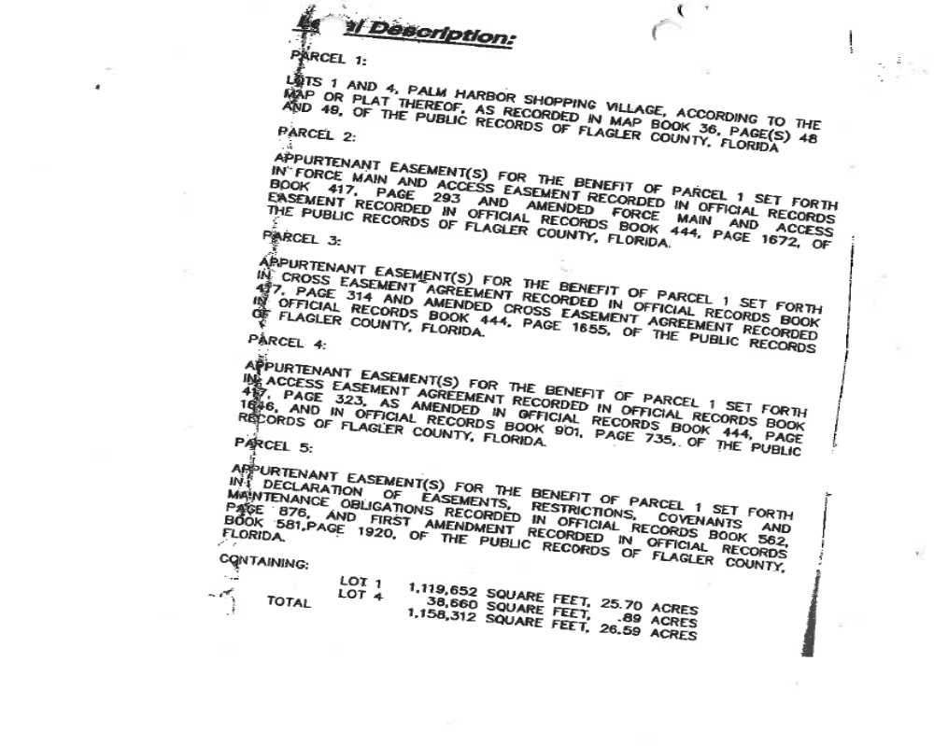

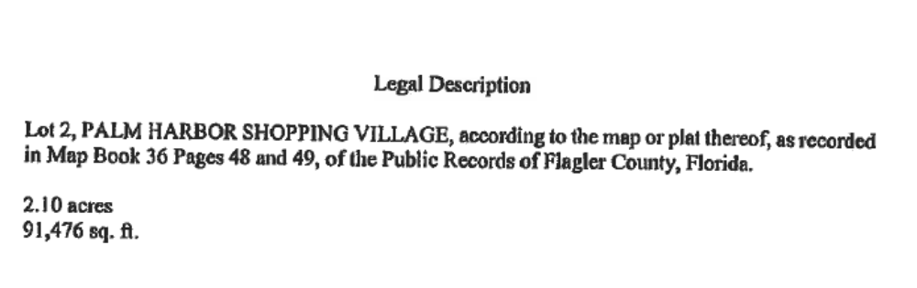

Exhibit 2
Conceptual Development Plan
Received
1.8.2014

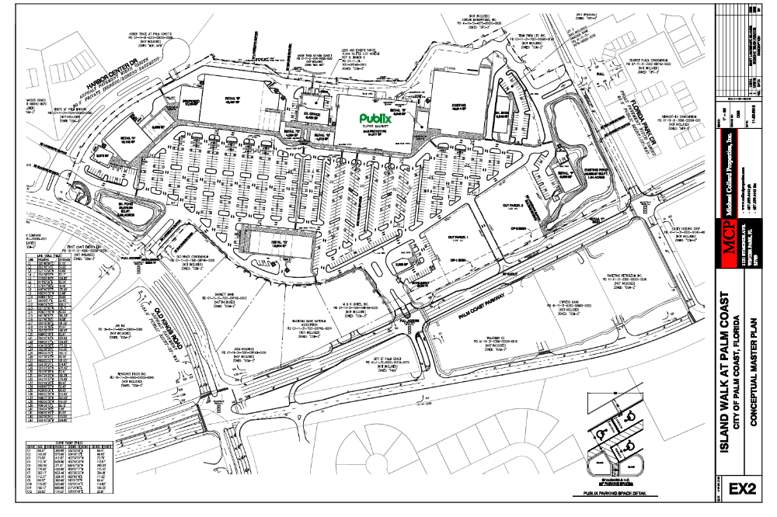

Exhibit 3
Conceptual Architecture



