CONTRACT FOR PURCHASE AND SALE
THIS CONTRACT FOR PURCHASE AND SALE ("Contract") is made by and between Moreno Eucalyptus, LLC , a limited liability company, (hereinafter referred to as "Seller"), with a principal address of 1 Mauchly, Irvine, CA 92618, (hereinafter referred to as "Seller"), and the CITY OF PALM COAST, FLORIDA, a Florida municipal corporation, ("Buyer") with a principal address of 160 Cypress Point Parkway, Ste. B-106, Palm Coast, FL 32164. For and in consideration of a valuable sum in dollars, the premises and the mutual covenants and obligations created hereby, as well as other good and valuable considerations, Buyer agrees to buy and Seller agrees to sell the following described real property subject to and upon the terms and conditions set forth below. The effective date of this Contract (the "Effective Date") shall be the date upon which the last of Seller and Buyer shall have signed this Contract.
ARTICLE I - PROPERTY
The real property (the "Property") is generally depicted in Exhibit "A" attached hereto and made a part
hereof.
ARTICLE II - PURCHASE PRICE
Purchase Price. The purchase price (the "Purchase Price") for the Property shall be Two Hundred Fifty Thousand AND 00/100 Dollars ($250,000.00).
ARTICLE III - CLOSING AND CLOSING DATE
The transaction contemplated by this Contract shall be closed (the "Closing"), the Purchase Price applied to closing costs and the deed, and the exclusive possession of the Property, free of all occupants, shall be delivered to Buyer at Closing. The closing date shall be on or before June 14, 2013.
ARTICLE IV - TERMS AND CONDITIONS The additional terms and conditions of this Contract are as follows:
4.1.Evidence of Title. Buyer shall select the title agent and Seller will pay for the owner’s title
policy search, examination, and related charges within thirty (30) days from the Effective Date, and shall obtain a title insurance commitment (the "Title Commitment") to issue an ALTA Owner's Title Insurance Policy - Form B from a title insurance company acceptable to Buyer (the "Title Insurance Company") in the amount equal to the Purchase Price of the property, naming Buyer as the proposed insured. The Title Commitment shall show good, marketable and insurable fee simple title to the Property to be vested in Buyer, liens, encumbrances, exceptions and qualifications which will not interfere with or impair the Property's use; exceptions permitted by the provisions of this Contract; and those exceptions which are capable of and are actually to be discharged by Seller at or before Closing (all other exceptions to title being deemed title defects for purposes of this contract). Legible and complete copies of all instruments listed as exceptions to title (commonly identified as Schedule B-II exceptions in the Title Commitment) shall be delivered with the Title Commitment. If title is found to be defective, Buyer shall, within ten (10) days from the date it receives the Title Commitment, notify Seller in writing to that effect specifying the defects. Seller shall have twenty (20) days from the receipt of Buyer’s notice specifying the title defects to cure the defects and, if after said period Seller shall not have cured the defects, or if Seller shall not have progressed to a point where the defects are certain to be remedied prior to Closing, or where the removal of such defects is not otherwise assured to Buyer's satisfaction, Buyer shall have the option of (i) accepting the title "as is" or (ii) terminating the Contract after which Buyer and Seller shall each be released from all further obligations to each other respecting matters arising from this Contract. Notwithstanding anything to the contrary contained herein, any assessments, special assessments, taxes, liens or other amounts related to stormwater fees accrued at time of Closing related to the Property as depicted in Exhibit A, shall be Buyer’s responsibility at Closing, and shall not be grounds for Buyer to terminate this Contract.

4.2. Survey. Buyer may, at Buyer’s expense, obtain a survey of the Property (the "Survey") prepared by a licensed Florida land surveyor within the last thirty (30) days before closing, or in the alternative, an update of an earlier survey re-dated to a point in time within the last thirty (30) days which complies with the Minimum Standard Detail Requirements for ALTA/ACSM Land Title Surveys adopted in 2005. If the Survey shows any encroachments onto the Property and/or improvements located outside its boundaries or encroachments by improvements principally located on the Property over required setback lines or over onto the property of others or onto any public right-of-way adjacent to the Property, or if it is apparent that the Property violates existing title covenants and/or applicable zoning laws or ordinances, Buyer shall notify Seller in writing to that effect specifying the defects. Seller shall have until thirty (30) days from receipt of Buyer's notice specifying the Survey defects in which to cure such defects. If after said period Seller shall not have cured the defects, or if Seller shall not have progressed to a point where the defects are certain to be remedied at or prior to Closing, Buyer shall have the option of (i) accepting the condition of the Property as disclosed in the Survey in an "as is" condition, or (ii) terminating the Contract, thereupon Buyer and Seller shall each be released from all further liabilities and obligations to each other with respect to all matters arising from this Contract.
4.3. Conveyance. Seller shall convey title to the Property to Buyer by Warranty Deed (the "Deed"), subject only to: (i) taxes for the year of Closing; and (ii) matters disclosed in the title evidence provided to and accepted or deemed accepted by Buyer.
4.4. Closing Affidavit. At the Closing, Seller shall furnish Buyer with an affidavit (i) testifying to the
absence of any claims, encumbrances, taxes, assessments, liens or potential lienors known to Seller not disclosed in the Title Commitment and Deed, (ii) further attesting that there have been no improvements to the Property by or through Seller for the ninety (90) day period immediately preceding the date of Closing, the cost of which remains unpaid, (iii) agreeing to take no action prior to recording the Deed which would adversely affect the title to the Property, (iv) testifying that possession of the Property is subject only to those matters accepted by Buyer pursuant to the terms hereof, if any, and that Seller is otherwise in exclusive, peaceable and undisputed possession of the Property, and (v) testifying that there are no actions or proceedings now pending in any state or federal court to which Seller is a party including, but not limited to, proceedings in bankruptcy, receivership or insolvency, which would affect the Property, the title to the Property or Seller's ability to close on the sale of the Property to Buyer except as disclosed in the Title Commitment. Seller shall also furnish such other evidence, affidavits or information required by the Title Insurance Company so that the Title Insurance Company will be able to eliminate all standard exceptions from the Title Commitment at Closing, except for taxes for the year of Closing which are not yet due, payable, or are otherwise disputed.
4.5. Place of Closing. Closing shall be held by express courier or at the offices of Buyer’s Title Company of choice or such other location as is mutually agreed upon by Buyer and Seller.
4.6. Documents for Closing. Closing Agent shall prepare the Deed, Seller's affidavit, closing statement, any corrective instruments that may be required in connection with perfecting title, and a general bill of sale conveying to the Buyer any and all personal property, fixtures and appurtenances, if any, relating to the Premises which conveyance shall be free and clear of any liens or encumbrances of any nature whatsoever.
4.7. Expenses. State documentary tax for the Deed and the cost of recording all corrective documents needed to complete the transaction shall be borne by Seller. Seller shall pay for the title insurance premium, recording the Deed and all fees and expenses arising from or associated with the simultaneous issuance of a lender's title insurance commitment and policy, if any, and any and all endorsements to such policy required by its lender.
Buyer shall be responsible for any applicable assessed stormwater fees accrued at time of Closing related to the Property.

4.8. Prorations and Escrow Balance. Taxes and other expenses and all revenue of the Property shall be prorated as of the date of Closing.
4.9. Proration of Taxes; Real and Personal. Taxes shall be prorated based upon the current year's tax based on the highest discount available at Closing. If the Closing occurs on a date when the current year's taxes are not fixed and the current year's assessment is available, taxes will be prorated based upon such assessment and the prior year's millage. If the current year's assessment is not available, then taxes will be prorated based on the prior year's tax; provided, however, if there are completed improvements on the Property by January 1st of the year of Closing, which improvements were not in existence on January 1st of the prior year, then the taxes shall be prorated to the date of Closing based upon the prior year's millage and an equitable assessment to be agreed upon between the parties, failing which request will be made to the county tax assessor for an informal assessment. If the Property is assessed as part of a larger tract of land and a "cut out" is not available from the tax assessor at the time of Closing, the taxes for the Property shall be estimated and prorated based upon the ratio of the size of the Property in relation to the overall tract of which the Property forms a part, taking into consideration matters of zoning as described in the tax assessor's records. Any tax proration based on an estimate may, at the request of either party, be subsequently readjusted upon receipt of the actual tax bill. This provision for reproration shall survive the Closing.
4.10. Special Assessment Liens. Special assessment liens which are certified, confirmed and ratified as of the date of Closing are to be paid by Seller. Special assessment liens which are certified, confirmed and ratified but payable in installments post Closing shall be paid in full by Seller at Closing. Special assessment liens pending as of the date of Closing shall be assumed by Buyer; provided, however, that if the improvements which form the basis for such special assessment are substantially completed as of the date of Closing they shall be deemed to have been certified, confirmed or ratified and Buyer shall, at Closing, be credited with an amount equal to the last estimate of the assessment for the improvement made by the appropriate public body. Notwithstanding anything to the contrary contained herein, any assessments, special assessments, liens, or other amounts related to stormwater fees accrued at time of Closing related to the Property, shall be Buyer’s responsibility at Closing, whether certified, confirmed, ratified, payable in installments, or otherwise.
4.11. Default. If Buyer fails to perform any of Buyer's covenants set forth in this Contract, the Deposit, if any, shall be paid to and retained by and for the account of Seller as agreed upon liquidated damages and in full settlement of any claims whatsoever. If Seller fails to perform any of Seller's covenants set forth in this Contract or fails to convey the Property when Seller is obligated to do so in accordance with the terms hereof, Buyer shall have, as its sole and exclusive remedies, the election of either (i) demanding and receiving a refund of the Deposit, if any, immediately or (ii) the right of specific performance against Seller.
4.12. Severability. If any one or more of the provisions of this Contract is held invalid, illegal or unenforceable, the remaining provisions of this Contract shall be unimpaired, and the remaining provisions of this Contract shall be construed to best carry out the original intent of the parties hereto.
4.13. Complete Agreement. This Contract evidences the complete understanding of the parties hereto as respects the matters addressed herein. No agreement or representation, unless set forth in this Contract, shall bind either of the parties hereto.

4.14 Notices. Notices to Seller and Buyer shall be deemed delivered (i) when hand delivered, or (ii) one (1) business day following delivery to an express delivery courier, such as Federal Express, or (iii) three (3) days following deposit in U.S. mail, certified, return receipt requested. Notice shall be given to the following addresses:
To Seller: Moreno Eucalyptus, LLC
1 Mauchly, Irvine CA 92618
To Buyer: City of Palm Coast
160 Cypress Point Parkway, Ste. B-106
Palm Coast, FL 32164
4.15. FIRPTA - Right to Withhold. Seller agrees that Buyer may deduct and withhold from the Purchase Price provided in Article II hereof, a tax in the amount of ten percent (10%) of the amount realized (as that term is used in Section 1445(a) of the Internal Revenue Code) by Seller pursuant to this Contract, except upon the occurrence of either (A) or (B) below:
- At or prior to Closing, Seller provides to Buyer a Certificate of Non-Foreign Status or a Non-USRPHC Statement described in and complying with Section 1445(b)(2) or (3) of the Internal Revenue Code of 1986, as amended (the "Code") (all references to Section or the Code include any successor provisions thereto and any Treasury Regulations promulgated in connection thereto) and Buyer has no knowledge or notice that such Certificate or Statement is false; or
- At or prior to Closing, Buyer received a withholding certificate described in Temp. Treas. Reg. Section 1.1445-3T or Rev. Proc. 85-41.
Buyer agrees that any amount deducted and withheld pursuant to this Section shall be remitted to the Internal Revenue Service in accordance with Section 1445 of the Code and the Regulations thereunder.
4.16. Environmental Status. Seller warrants and represents to Buyer that, to Seller's knowledge, (i) the Property is free of all hazardous waste or substances except as may be permitted by applicable law; (ii) that the Property has been operated and maintained in compliance with all applicable environmental laws, statutes, ordinances, rules and regulations; (iii) no other release of any hazardous waste or substances has taken place on the Property, (iv) no migration of hazardous waste or substances has taken place from the Property which would cause the release of any hazardous waste or substance on any adjoining lands or any other lands in the vicinity of the Property; and (v) there are no bulk or underground tanks on or in the Property, and, no bulk or underground storage tanks have ever been located on or in the Property.
The term hazardous waste or substances shall include those substances included within the definitions of "hazardous substances", "hazardous materials", "toxic substances", or "solid waste" in CERCLA, RCRA, and the Hazardous Materials Transportation Act, 49 U.S.C. Section 1801, et seq., and in the regulations promulgated pursuant to said laws or any replacement thereof; such other substances, materials and wastes which are or become regulated under applicable local, state or federal law, or which are classified as hazardous or toxic under federal, state, or local laws or regulations.
Seller has no notice or knowledge of the on-site existence of any “Endangered and Threatened Species,” flora and fauna as identified by the U.S. Fish and Wildlife Service's "List of Endangered and Threatened Wildlife and Plants" as may be amended from time to time. Seller further warrants no knowledge of the on-site existence of any upland conservation areas which are preserved, or may be preserved, for the purposes of providing of wildlife habitat.
The provisions of this Section 4.16 shall survive the Closing or earlier termination of this Contract.
4.17. Right of Inspection. During the term of this Contract, Buyer, its agents, employees and representatives, may have access to the Property and the records of the Property (including those on file with any governmental agency) at all reasonable times subsequent to the Effective Date of this Contract with the right, at Buyer's expense, to inspect the Property and to conduct all tests and borings thereon as Buyer, its licensed engineers, surveyors and the like shall deem reasonably necessary or desirable to fulfill the tests and investigations contemplated by the Contract. Any entry on or to the Property by Buyer or its authorized representatives pursuant to the provisions hereof shall be at the risk of Buyer, and Buyer hereby indemnifies, protects, and holds Seller harmless and agrees to defend Seller from and against any and all claims, demands, losses, damages, and liabilities (including but not limited to personal injury and property damage claims and mechanics' or other liens), together with related costs and expenses, including reasonable attorney fees and litigation costs, caused by Buyer or Buyers' agents on or to the Property. In addition, Buyer shall keep the Property free from any liens which could arise as a result of the exercise by Buyer of any of its rights hereunder. The provisions of this Section 4.17 shall survive the Closing or earlier termination of this Contract.
4.18. WAIVER OF TRIAL BY JURY. SELLER AND BUYER HEREBY MUTUALLY, VOLUNTARILY AND INTENTIONALLY WAIVE THE RIGHT EITHER MAY HAVE TO A TRIAL BY JURY IN RESPECT OF ANY LITIGATION BASED HEREON OR ARISING OUT OF, UNDER OR IN CONNECTION WITH THIS CONTRACT OR ANY AGREEMENT CONTEMPLATED TO BE DELIVERED IN CONJUNCTION THEREWITH, OR ANY COURSE OF CONDUCT, COURSE OF DEALING, STATEMENTS (WHETHER ORAL OR WRITTEN) OR ACTIONS OF EITHER PARTY. THIS PROVISION IS A MATERIAL INDUCEMENT FOR EACH OF SELLER AND BUYER ENTERING INTO THIS CONTRACT.
ARTICLE V - SPECIAL CONDITIONS
Seller has made a limited number of representations and warranties to Buyer in this Contract. In consideration of Buyer waiving additional conditions, representations or warranties from Seller, Seller and Buyer hereby agree as follows:
5.1. Condition Precedent. Buyer’s obligation to close under this Contract shall be subject to the satisfaction of the following conditions precedent enumerated below. In the event any one of these conditions is not satisfied for any reason whatsoever, then this Contract shall terminate, and Buyer and Seller shall be fully relieved from all further rights and responsibilities under this contract.
- The complete execution of this Contract by Seller and Buyer and the approval of this Contract by the Palm Coast City Council at a public meeting, pursuant to §166.045, Fla. Stat.
- No action, suit, proceeding, or official investigation shall have been threatened, announced, or commenced by any person or federal, state or local government authority or agency that seeks to enjoin, assess civil or criminal penalties against, or obtain any judgment, order, or consent decree, with respect to either party hereto, in connection with their respective representations and obligations under this Contract.
- Seller shall fully comply with the provisions of Section 286.23, Florida Statutes by executing
and delivering an Affidavit in the form of the Affidavit of Interest in Real Property - Florida Statute 286.23, a copy of which is attached hereto as Exhibit “B.”
5.2. Inspection Period. Buyer shall have until the date of Closing (herein the "Inspection Period") in which to conduct an investigation of the Property, including, by way of illustration and not in limitation and subject to Section 4.17: inspections as to the physical condition of the Property, investigate the availability of utilities, status of zoning or ability to rezone, zoning codes, building codes, physical condition and any other condition or characteristic of the Property which Buyer may deem necessary or relevant to Buyer in purchasing the Property. Should Buyer for any reason become dissatisfied or concerned with the result of any such investigation, search, inquiry or report as contemplated hereby, then Buyer may, prior to the expiration of the Inspection Period, terminate this Contract by written notice thereof to Seller. Notwithstanding anything to the contrary contained herein, if Buyer has not terminated this Contract by written notice delivered to Seller prior to Closing, then the Deposit (if any) shall be applicable to the Purchase Price but non-refundable, other than pursuant to Section 5.1 hereof, except in the event of a default by Seller hereunder.
5.3.
Platting and Zoning Requirements. If the Property or any parts thereof, are not platted or suitably zoned, or if variances from the existing zoning classification are required by Buyer, Buyer shall have the right to have the zoning classification or requirements changed, and take such action, including but not limited to, requests or approvals for rezoning submittals, zoning variances, environmental permits, water management district permits, concurrency determinations and reservations, and development agreements, as Buyer deems necessary related to the Property. Seller shall execute whatever instruments are necessary and take whatever action is necessary and fully cooperate to assist Buyer in obtaining such rezoning or variances or other approvals for the Property. Seller agrees to cooperate with all State, Federal, and local governmental review procedures which are required as part of the local zoning process. Further, Seller agrees to timely execute the required documents in order to avoid delays in the local zoning process related to the Property. If such rezoning or variance is denied then, at Buyer's election, this Contract shall terminate, and the Deposit shall be refunded to Buyer, unless Buyer waives such zoning requirements in writing.
5.4. Brokerage. Both parties agree that Buyer and Seller hereby represent to each other that neither party has dealt with or engaged a broker with respect to the transaction contemplated herein. Each party hereby agrees to indemnify the other from and against any claim for brokerage commission or finder's fee asserted by any other person, firm or corporation claiming by, through or under said party.
5.5. Seller Warranties. Buyer acknowledges that, except as expressly stated above, Seller has made no representations or warranties, written or oral, express or implied, with respect to the Property. During the period that this Contract is in effect, Seller shall maintain the Property in its current condition, reasonable wear and tear excepted.
5.6. Assignment. Buyer shall have the right to assign its rights and privileges under this Contract to any entity which controls, is controlled by or under common control with Buyer; provided, however, that such assignment shall not relieve Buyer of any obligations hereunder.
5.7. Seller Not to Convey. Seller shall not convey any interest in the Property after the signing of this Contract without the prior joinder or written consent of the Buyer.
5.8. Extensions of Closing Date. Buyer shall have the unilateral and absolute right to exercise one thirty (30) day extension of the Closing Date. Buyer shall exercise the extension by providing at least three (3) days written notice to Seller. Any other extension shall be by mutual agreement of the parties.
5.9. Headings; Entire Agreement; Governing Law. The headings contained in this Contract are for reference purposes only and shall not affect in any way the meaning or interpretation of this Contract. This Contract constitutes the entire agreement and supersedes all prior agreements and understandings, both written and oral, among the parties with respect to the subject matter hereof, and this Contract may be executed in separate counterparts, each of which shall be deemed an original, and all which shall constitute one and the same instrument. This Contract shall be governed in all respects, including validity, interpretation and effect, by the laws of the State of Florida.

5.10 Stormwater Easement Conveyance to Seller. Simultaneously with the Closing hereof, Buyer shall convey to Seller a stormwater easement according to the terms and conditions as set forth in the form easement attached hereto as Exhibit C.

IN WITNESS WHEREOF, the parties have executed this instrument as of the day and year indicated below.
Signed, sealed and delivered SELLER:
in the presence of:

(print name) Signature
(print name) Printed Name

Title

Date

BUYER: CITY OF PALM COAST

By:
Jim Landon, City Manager
ATTEST:

By:_____________________________ Date:
Virginia A. Smith, City Clerk

APPROVED BY (Initials and date):
/___/___/___ Responsible Department Director
/___/___/___ City Finance
/___/___/___ City Attorney
EXHIBIT “A”
[LEGAL DESCRIPTION]
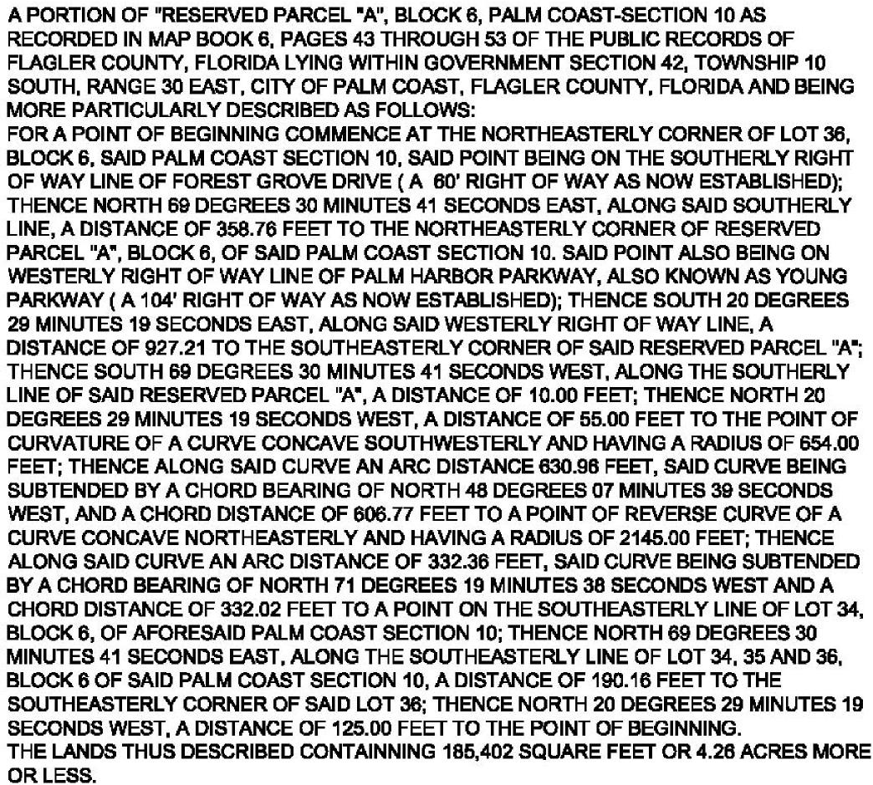

EXHIBIT “B”
AFFIDAVIT OF INTEREST IN REAL PROPERTY – F.S. 286.23
THIS AFFIDAVIT OF INTEREST IN REAL PROPERTY is made and entered into this _____ day of
, 2013, for the sole purpose of compliance with Section 286.23 of the Florida Statutes.
The undersigned hereby swears and affirms that the following is true:
- The undersigned is the of MORENO EUCALYPTUS, LLC, a
limited liability company, the legal title holder of the real property described on the
attached Exhibit “1.”
- The name(s) and address(es) of every person having a beneficial interest in the real property
described on the attached Exhibit “1” however small or minimal is/are”:
 | Name | Address

FURTHER AFFIANT SAYETH NAUGHT.

[SIGNATURES ON FOLLOWING PAGE]

Signed, sealed and delivered in our presence:
By:
Print Name:
Print name: Title:
Print Name:
STATE OF
COUNTY OF
SWORN TO and subscribed before me this _____ day of , 2013, by
, the of , (check one)
who is personally known to me or who provided as identification.
Print Name:
Notary Public – State of Florida

EXHIBIT “1”
[LEGAL DESCRIPTION]
