EXHIBIT A
PALM COAST SEMINOLE GROUP, LLC
PALM COAST ONE GROUP, LLC

MASTER PLANNED DEVELOPMENT AGREEMENT
Return to:
City Clerk
City of Palm Coast
160 Cypress Point Pkwy, Ste. B106
Palm Coast, Florida 32164

------------------- | [SPACE ABOVE THIS LINE FOR RECORDING DATA] | --------------------

MASTER PLAN DEVELOPMENT AGREEMENT BETWEEN
THE CITY OF PALM COAST AND PALM COAST SEMINOLE GROUP, LLC,
PALM COAST ONE GROUP, LLC

THIS MASTER PLAN DEVELOPMENT AGREEMENT, (herein referred to as the “Development Agreement”) is made and executed this day of , 2011, by and between the CITY OF PALM COAST, a Florida municipal corporation (herein referred to as the “City”), whose address is 160 Cypress Point Parkway, Suite B-106, Florida, 32164, and Palm Coast Seminole Group, LLC., a Florida limited liability company, and Palm Coast One Group, LLC., a Florida limited liability company, (herein referred to from time-to-time as the “Developer” regardless of whether singular or plural ownership status) whose address is 1 Florida Park Drive, Suite 301, Palm Coast, Florida 32137.
WITNESSETH:
WHEREAS, the Developer is the fee simple title owner of certain real property consisting of approximately 85 acres located at the northeast corner of U.S. Route 1 and Seminole Woods Blvd. in the City of Palm Coast, Flagler County, Florida, more particularly described in Exhibit “1” (herein referred to as the “Subject Property”); and
WHEREAS, the City Council finds that the Property is a critical component of this community in that it positively affects the City in many ways including , but not limited to health, safety, welfare, emergency services and economic development; and
WHEREAS the City finds that to ensure the Developer can properly grow and develop to meet the needs of the community the terms and conditions of this Development Agreement are necessary; and
WHEREAS, as a result, the Developer requests approval for a Master Plan Development for the development of commercial, with residential option, open space and preservation of sensitive lands located on the Subject Property per the conditions set forth in this Development Agreement (the “Project”); and
WHEREAS, the Developer voluntarily agrees with the conditions, terms, and restrictions hereinafter recited, and has agreed voluntarily to their imposition as an incident to development of the Subject Property; and
WHEREAS, the City of Palm Coast City Council (“City Council”) finds that this Development Agreement is consistent with the City’s Comprehensive Plan (the “Comp Plan”) and Unified Land Development Code (the “LDC”) and that the conditions, terms, restrictions, and requirements set forth herein are necessary for the protection of the public health, safety, and welfare of the citizens of the City; and
WHEREAS, the City Council further finds that this Development Agreement is consistent with and an exercise of the City’s powers under the Municipal Home Rule Powers Act; Article VIII, Section 2(b) of the Constitution of the State of Florida; Chapter 166, Florida Statutes; the City of Palm Coast City Charter; other controlling law; and the City’s police powers; and
WHEREAS, this is a non-statutory Development Agreement which is not subject to or enacted pursuant to the provisions of Sections 163.3220 -163.3243, Florida Statutes.
NOW, THEREFORE, it is hereby resolved and agreed by and between the City and the Developer that the Developer’s application for a Master Plan Development is approved subject to this Development Agreement’s following terms and conditions:
SECTION 1. RECITALS.
The above recitals are taken as true, incorporated herein by this reference and form a material part of this Development Agreement upon which the City and the Developer have relied.
SECTION 2. REPRESENTATIONS OF DEVELOPER.
(a). The Developer hereby represents and warrants to the City that the Developer is the owner of the Subject Property in accordance with the title opinion provided by the Developer to the City issued by an attorney licensed to provide services in the State of Florida with said title opinion showing all liens, mortgages, and other encumbrances not satisfied or released of record relative to the Subject Property.
(b). The Developer represents and warrants to the City that it has the power and authority to enter into and consummate the terms and conditions of this Development Agreement; that all acts, approvals, procedures and similar matters required in order to authorize this Development Agreement have been taken, obtained or followed, as the case may be; that this Development Agreement and the proposed performance of this Development Agreement by the Developer is not an ultra vires act; and that, upon the execution of this Development Agreement by the parties, this Development Agreement shall be valid and binding upon the parties hereto and their successors in interest.
(c) The Developer hereby represents to the City that all required joinders and consents have been obtained and set forth in a properly executed form on this Development Agreement. Unless otherwise agreed to by the City, all liens, mortgages, and encumbrances not satisfied or released of record must be subordinated to the terms of this Development Agreement and joinders must be executed by any mortgagees. It is the responsibility of the Developer to ensure that said subordinations and joinders occur in a form and substance acceptable to the City Attorney prior to the City’s execution of this Development Agreement. If the Developer fails to attain the joinder and consent, then the Developer shall lose all rights and benefits deriving hereunder.
SECTION 3. APPROVAL OF MASTER DEVELOPMENT PLAN AND DEVELOPMENT REVIEW PROCESS
(a). The City Council, at its regular meeting on of 2011, adopted the Developer’s application for a Master Plan Development affecting the Subject Property subject to the terms and conditions of this Development Agreement.
(b). The Developer acknowledges that if this Development Agreement is ever terminated, the approval shall be deemed null and void and the land uses approved for the Subject Property shall no longer be permitted, unless otherwise approved by the City Council.
(c). The current provisions of the LDC shall be applicable to the Subject Property unless otherwise specifically stated herein. Any City Code provision not specifically identified will not be affected by the terms of this Development Agreement, and will be subject to enforcement as if no Development Agreement were in effect.
(d). As part of the Master Plan Development approval the Master Development Plan (Composite Exhibit “2”) shall be deemed the controlling master plan for the Project. The Master Development Plan (“MDP”) depicts the Project characteristics and delineates the overall property boundaries, proposed planning areas, and conservation areas. The Master Development Plan also illustrates the general location of access points, driveways, landscape buffers, and other pertinent information. Furthermore, the Subject Property may be developed into seven (7) Planning Areas as depicted by the Master Development Plan, attached as Exhibit 2, which includes a Development Criteria Table illustrating the primary development components: building area, parking, storm water, and open space, subject to LDC requirements. The development intensities and densities are neither a guarantee nor a requirement to build.
The Master Development Plan contains a level of detail satisfactory to permit the Project to proceed directly to preliminary plat, final plat, and/or site plan, as applicable. Applications may be submitted simultaneously, subject to review and approval as provided for in the LDC. The City Manager, as the Land Use Administrator (LUA), or his designee, is authorized to approve construction plans and preliminary plats for the Project. Final Plat approval shall require approval by City Council.
SECTION 4. MODIFICATIONS TO THE CONCEPTUAL DEVELOPMENT PLAN:
At Site Plan Review, the exact location and number of structures, roadways, primary sidewalk/pathway system and other improvements required to support the proposed use shall be established in accordance with the Master Development Plan. Site plans submitted in conformance with the MPD and LDC do not require amendment of the Development Agreement. Development intensities and densities are transferrable between Planning Areas without modification to this Development Agreement provided all development components illustrated in Development Criteria Table No. 1 are adjusted proportionately keeping the overall intensity (including parking, open space, etc.) of the MDP. Modifications to the exact location and number of structures, roadways, primary sidewalk/pathway system and other improvements may be requested by the Developer and approved by the LUA during review of construction documents, site plans for the Project or portions thereof, as long as the development standards contained in this Development Agreement are substantially maintained. Moreover, the LUA is authorized to approve modifications to the Master Development Plan, construction documents, and final site plans for the Subject Property or portions thereof (collectively, “Plans” and individually, a “Plan”).
SECTION 5. PERMITTED USES
The Developer agrees to fully comply with the following Use Restrictions on the Subject Property. The Developer may construct a mix of uses consistent with the Master Development Plan and Section 5.1 of the LDC (2010) (incorporated herein by reference) except as otherwise provided in Section 6 of this Development Agreement.
5.1 USE RESTRICTIONS.
The Planning Areas consist of residential and commercial land uses and shall comply with the various standard zoning districts defined within the LDC in full force and effect at the time of site plan approval as follows:
TABLE 1
COMPATIBLE DEVELOPMENT
STANDARDS
Planning  Area | Compatible Development Standards**
A | COM-3
B * | COM-3
C | COM-3,  MFR-2
D * | COM-3
E * | COM-3,
F | COM-3
G | COM-3  MFR-2
H and I | PRS ***

* NOTE: For Parcels B, D, and E, uses and site design are subject to City of Palm Coast Wellfield Protection Requirements.
** Unless otherwise specifically called for herein, the uses identified in Table 3.4 of the LDC shall govern the uses allowed within the MPD, according to the designated Compatible Development Standard designation. Once a residential or non-residential use has been established through site plan approval for Planning Areas C or G, the balance of those Planning Areas must develop with the same assigned Compatible Development Standard as the established use
*** Wetland/Conservation and Mitigation
5.2 VEHICULAR/NON-VEHICULAR, PEDESTRIAN, ACCESS AND PARKING ACCESS, AND INTERCONNECTIVITY:
The Development Plan reflects conceptual vehicular traffic circulation systems within the Subject Property with adjacent rights of ways. All non-residential uses shall have access to either a dedicated roadway or internal driveway, provided that if access is to an internal driveway, the internal driveway must be properly designed for unobstructed traffic circulation through the Subject Property to a dedicated roadway . The City shall be granted access to all roadways to ensure that public safety is maintained. U.S. Route 1 vehicular access locations shall be limited to those approved by the City of Palm Coast and Florida Dept. of Transportation. Subject to engineering design, US 1 access shall comply with FDOT standards. Subject to engineering design, Seminole Woods Blvd. access shall comply with City of Palm Coast requirements and standard engineering practice and is limited to a directional median break at a distance of 440 ft. from the intersection of US 1; right in/right out entrance at a distance of 250 ft. from the intersection of US 1; and right in only at a distance of 125 ft. from the intersection of US 1.

SECTION 6. PROHIBITED USES
The Developer agrees to prohibit the following uses :

6.1 FOR Planning Areas A-E :
Stadiums and Athletic/Sports Arenas, Outdoor Kennels and Animal Boarding, Truck and Heavy Equipment Driving Schools, Passenger Transit or Rail Stations.

6.2 FOR Planning Areas F-G
Passenger Transit or Rail Stations.

This prohibition does not prevent future owners or applicants from requesting a modification of this Development Agreement to allow any of the above uses, however associated wellfield protections regulations remain applicable.

SECTION 7. LAND DEVELOPMENT CODE NON-APPLICABILITY.
The development of the Project shall proceed in accordance with the terms of this Development Agreement. In the event of an inconsistency between the terms of this Development Agreement and the LDC, the terms of this Development Agreement shall prevail. Where specific requirements are not contained in this Development Agreement, the LDC shall apply.
7.1 SIGNAGE:
All signage shall comply with the LDC. Planning Areas A-E shall be subject to a master signage program that includes an easement for a City identification sign.
SECTION 8. FACILITY COMMITMENTS.
(a). Unless otherwise described elsewhere in this Development Agreement, the Developer agrees that the City is not responsible for the construction or creation of public facilities or capacity to facilitate the development of the Subject Property. No site plan development orders or residential preliminary plats shall be issued for the Subject Property unless adequate capacity of concurrency monitored facilities is available concurrent with the impact on said facilities by the development. Once Developer complies with concurrency requirements, Developer may develop in accordance with approved plans.
(b). The Developer agrees to complete, at a minimum, the following facility/infrastructure, and to grant the following rights, at the Developer’s sole and exclusive expense, as a condition of this development approval in advance of or simultaneously with the development of the Subject Property, in addition to the payment of all impact fees:
(i) Construct road connections to U.S. Hwy. 1 and complete Shady Oaks Drive as generally depicted in Exhibit 2.
(ii) Construct all on-site improvements, including the parking areas,
utilities, storm water management system, lighting, and perimeter buffer
landscaping.
(iii) Construct offsite turn lane improvements to support ingress and egress, including provision of any additional right of way necessary for such improvements.
(iv). The Developer shall grant any and all necessary easements to the City which are deemed necessary to serve the subject property with public
utilities and infrastructure.
(v). Record conservation easements Planning Areas H & I (preservation lands) for perpetual maintenance by an entity suitable to the City.

(vi). The Developer shall provide an internal integrated system of sidewalks and natural pathways consistent with the requirements of the LDC. The City may require the developer to pay into the sidewalk improvement fund for those sections along US 1 in lieu of construction.
(c). The Developer agrees that the City has shown an essential nexus between a legitimate City interest and the conditions, if any, imposed herein. The Developer further agrees that all proposed conditions are roughly proportional to the impact of the development upon the public based upon an individualized determination by the City that the required conditions are related in both nature and extent to the impacts of the proposed development.

SECTION 9. DEVELOPMENT STANDARDS.
9.1 GENERAL: The intensities and densities are being approved, subject to location of driveways, landscape buffers, and provision of other infrastructure. Each Planning Area of the Project will include infrastructure to support the proposed uses, including water and wastewater service, shared parking and driveways, master stormwater facilities, pedestrian and vehicular connectivity between sites, structures and uses provided these elements are controlled by a Property Owners Association.
9.2 PARKING: Parking requirements shall be reviewed at the technical site plan review level and based upon the standards in effect in the LDC at the time of submittal.
9.3 OPEN SPACE: Minimum open space shall be forty percent (40%) of each Planning Area. Open space shall be defined to include stormwater retention, buffer, landscape, and setbacks as illustrated in the Development Criteria Table, attached in Exhibit 2. Flexibility to the minimum open space requirements shall be as provided by the LDC, which may include, but not limited to, green building principles, land donation, or other applicable mechanisms. Open Space shall be maintained by a property owners association, covenants & easements, or other method satisfactory to the Developer and the City.
9.4 WATER/WASTEWATER: The Project is located wholly within the City limits and is therefore within the City’s water and wastewater service areas. All proposed permanent uses within the Project will be served by central water and sewer services. The City shall be the potable water and wastewater service provider for the Project upon payment of applicable fees. The City is under no obligation to accept the dedication of any facility.
9.5 TRANSPORTATION CONCURRENCY: Pursuant to the LDC, the parties agree that the Developer will be required to evaluate the square footages and residential units depicted in Planning Areas A-E for traffic concurrency at site plan submittal for any of the planning areas. Planning Areas F & G may be evaluated separately from Planning Areas A – E due to their physical separation.
9.6 DRAINAGE: The Project shall include a Master Stormwater System (“MSS”). The MSS design shall meet, and be governed by, applicable SJRWMD and City of Palm Coast rules and regulations. The MSS will include management of stormwater runoff lakes, structures, piping, and facilities. Best Management Practices (BMPs) to treat, control, attenuate, and convey stormwater and surface waters may include, but are not limited to, vegetated natural buffers, swales, dry retention and wet detention. The applicant shall include the culvert capacity at Seminole Woods Blvd. if discharge is routed to this facility.
9.7 LANDSCAPING: All landscaping shall comply with the LDC. In addition, the Project shall use irrigation source priorities of the City from highest to lowest preference: reclaimed water, stormwater, lake or canal, ground water (well). No potable water shall be used for irrigation, except on a temporary basis until stormwater or reclaimed water source is available, or if approved by the City.
9.8 LIGHTING: All exterior Lighting shall incorporate dark sky principles unless otherwise prohibited within the Comprehensive Habitat Management Plan as detailed within Sections 9.11 and 9.16, and shall comply with the LDC and be architecturally consistent with the Subject Property.
9.9 FIRE PROTECTION: The Project shall comply with the City’s fire protection requirements, including but not limited to stabilized access. Fire protection requirements for the Project will be met through a system of fire hydrants installed on the site by the Developer in accordance with City standards. The locations of fire hydrants shall be shown on all construction documents or site plans .
9.10 UTILITIES: All internal utility lines for the Project shall be placed
underground.
9.11 INTERCONNECTIVITY: All buildings within each Planning Area shall be interconnected by roadways, driveways, sidewalks and paths as called for by the City’s Comprehensive Plan and LDC except where separated by preservation/mitigation areas.
9.12 RESOURCE PROTECTION: A Comprehensive Habitat Management Plan (HMP) shall be provided to the City prior to the first development application. The intent of the HMP is to ensure a sustainable plan that incorporates ecological elements and development activities cohesively to ensure perpetual resource protection. HMP elements shall include, but are not limited to, on-site wetland mitigation plan, Bear Smart Community principles, dark-sky lighting, wildfire mitigation, wildlife-human conflict strategies, wildlife crossings, environmental education literature and planning, etc. The City shall coordinate with Florida Fish and Wildlife Conservation Commission (FWC) and St. Johns River Water Management District (SJRWMD) to ensure that the plan does not conflict with any agency goals or regulations.
A Comprehensive Plan Future Land Use Map designation of Conservation shall be administratively applied as conservation easement(s) are executed through platting or other approvals.
9.13 FLOODPLAIN PROTECTION: Encroachment into Special Flood Hazard Area(s), primarily Planning Areas D and E, shall be minimized to the greatest extent practical and comply with the LDC and subsequent amendments. Utilizing best management practices to reduce grading impacts in the flood plain will constitute minimization.
9.14 GREEN DEVELOPMENT PRACTICES: The Developer shall pursue the feasibility of Green Development designation from the Florida Green Building Coalition (FGBC) or LEED Neighborhood Development designation from U.S. Green Building Council.
9.15 WELLFIELD PROTECTION: All development activities shall ensure that improvements will not affect the potable water resources and shall comply with the LDC and subsequent amendments.
9.16 FLORIDA BLACK BEAR PROTECTION: Bear Smart Community principals shall be incorporated into the overall development and shall be referenced within the Seminole Pointe Comprehensive Habitat Management Plan (HMP) as referenced in Section 9.12. For reference purposes, Bear Smart Community principles are documented within the draft Black Bear Management Plan produced by the Florida Fish and Wildlife Conservation Commission (FWC). Principal elements include, but are not limited to, a human-bear conflict management plan, education plan, bear-proof waste strategies, bear-smart by-laws, etc.
9.17 WETLANDS: The SJRWMD and US Army Corps of Engineers will require the developer to obtain permits and provide mitigation for applicable wetland impacts. The SJRWMD has already approved the wetland limits and has approved a binding formal wetland jurisdictional determination (Permit 16-035-122065-1). The Developer will obtain all necessary permits, including UMAM analysis. The UMAM analysis will be provided to the City for review and approval to ensure that SJRWMD approved activities meet the requirements of Section 10.01 Wetland Resources, Unified Land Development Code.
9.18 LOW IMPACT DEVELOPMENT PRACTICES: To further conservation practices identified in the LDC, the Project shall incorporate into the construction, operation and maintenance of all facilities conservation strategies to include but not limited to:
1. Water Conservation
    - Native, drought tolerant plant materials
    - SJRWMD waterwise Florida landscapes or comparable actions
    - Turf grass – Irrigated area(s) shall not exceed 50% of landscape area(s)
    - Separate irrigation zones shall be required for turf, non-turf areas
    - Landscape areas shall not be irrigated using high-volume irrigation system unless high pressure compensating spray heads are utilized
    - All irrigation systems shall employ a rain shut-off device such as a soil moisture sensor
9.19 PROHIBITION OF DISCHARGES: The Developer shall comply with the City of Palm Coast Code of Ordinances, Article VI, Prohibition of Discharges, and all applicable local, State, Federal and City water quality laws, rules, regulations and ordinances.
9.20 STORMWATER POLLUTION PREVENTION: A stormwater pollution prevention plan ("SWPPP') shall be attached to and incorporated into the construction and permit documents pursuant to the requirements of applicable federal, state, and City regulations.
9.21 WILDLIFE PROTECTION: In the event that listed species have been determined to be residing on, or otherwise be significantly dependent on the Subject Property, the Developer shall obtain the necessary permits from the FWC or other applicable agencies. Activities associated with listed flora and fauna shall comply with the LDC.
SECTION 10. DEVELOPMENT STANDARDS
10.1 DIMENSIONAL STANDARDS - NON RESIDENTIAL ;
The following non-residential building setbacks shall supersede current LDC requirements:
- Building Setbacks:
Lot Lines - 0
Internal Roads - 20
U.S. Hwy 1 - 60
Seminole Woods Blvd. - 75
* Landscape buffer width of 35 feet adjacent to Seminole Woods Blvd. can be reduced if authorized use of all or part of the existing 40 ft. drainage easement adjacent to the Seminole Woods Blvd. northern right of way is granted.
10.2 DIMENSIONAL STANDARDS RESIDENTIAL ;
Residential development components shall meet all setback, ISR, Max. Building height, etc. for the Multifamily Residential High (MFR-2) zoning district for site plan approval.
10.3 IMPERVIOUS: Maximum impervious area shall be limited to seventy percent (70%) of each planning area gross area. Moreover, the minimum pervious area shall be thirty percent (30%) of each planning area gross area. The terms “pervious” and “impervious” are defined by the LDC.
10.4 FAR: The FAR for the development of the Subject Property shall be calculated based on the ratio of all developed buildings to the total area of the developable planning areas.
10.5 INTENSITY:
Intensity shall not exceed that depicted on the overall MPD.
10.5 ARCHITECTURE/PUBLIC SPACES: The architectural features of the Project shall comply with applicable standards of the LDC; Chapter 13, ARCHITECTURAL DESIGN GUIDELINES; in effect at the time of development. An Architectural Theme shall be established for non-residential uses with the first site plan submittal for Planning Areas A through E. Parcel C shall be compatible with the established residential areas. A separate Theme for Planning Areas F and G is possible due to the physical separation from the balance of other Planning Areas of the site. Public Spaces shall serve as focal points and include designated sitting areas, plazas, fountains, and other hardscape improvements, and shall be provided for each facility within the Project in keeping with the scale of the respective facility. In addition, the internal pedestrian/pathway system shall include, at minimum, benches strategically situated along the internal walkway corridors.
SECTION 11. LIST OF OUTSTANDING PERMITS/APPROVALS, AND PROPER SEQUENCING.
The failure of the Development Agreement to address any specific City, County, State, or Federal permit, condition, term, or restriction shall not relieve the Developer or the City of the requirement of complying with the law governing said permitting requirements, conditions, terms, or restrictions.
SECTION 12. DEVELOPMENT FEES.
The Developer acknowledges and agrees that the City has enacted and may in the future increase the amount of citywide impact fees or similar exactions. Except as provided for herein, the Developer acknowledges that the Subject Property shall be subject to all fees in effect at the time of permitting.
SECTION 13. COMMON AREAS AND MAINTENANCE.
If the development on the Subject Property is to include any common areas, to ensure the long-term ownership, maintenance, and control of those areas, prior to the issuance of any building permits, the Developer shall establish an association, in accordance with Florida law, comprised of the owners of lots or parcels within the Project (the “Association”). The Association documentation shall be subject to the prior reasonable review and approval of the City to ensure adequate provisions for the on-going care and maintenance of the common areas. The documentation, whether contained in a deed restriction or otherwise, shall provide for the permanent maintenance of the Common Areas by the Association, minimum insurance requirements for the Association, adequate mechanisms to force financial participation by members of the Association, and restrictions on the ability to amend these requirements without the City’s approval. The City shall be entitled to enforce the restrictions, if so desired.
SECTION 14. BREACH; ENFORCEMENT; ALTERNATIVE DISPUTE; CONFLICT RESOLUTION.
(a). In the event of a breach hereof by either party hereto, the other party hereto shall have all rights and remedies allowed by law, including the right to specific performance.
(b). In the event that a dispute arises under this Development Agreement, and if the City and Developer are unable to resolve the issues, the parties shall attempt to resolve all disputes informally. In the event of a failure to informally resolve all disputes, the City and Developer agree to engage in mediation before a certified Circuit Court mediator selected by the parties. In the event that the parties fail to agree to a mediator, a mediator with the Florida Conflict Resolution Consortium or, if unavailable, a certified mediator may be selected solely by the City. The parties shall equally pay all costs of mediation.
(c) In the event of conflict between the terms of this Development Agreement and the Conceptual Development Plan, the provisions of this Development Agreement shall prevail.
SECTION 15. NOTICES.
(a). All notices required or permitted to be given under this Development Agreement must be in writing and must be delivered to the City or the Developer at its address set forth below (or such other address as may be hereafter be designated in writing by such party).
(b). Any such notice must be personally delivered or sent by registered or certified mail, overnight courier, facsimile, or telecopy.
(c). Any such notice will be deemed effective when received (if sent by hand delivery, overnight courier, telecopy, or facsimile) or on that date which is three (3) days after such notice is deposited in the United States mail (if sent by registered or certified mail).

(d). The parties’ addresses for the delivery of all such notices are as follows:
As to the City: City Manager
160 Cypress Point Pkwy, Suite B-106
Palm Coast, Florida, 32164

As to the Developer: Gus Simos
Palm Coast Seminole Group, LLC.
Palm Coast One Group, LLC
1 Florida Park Drive Suite 301
Palm Coast, FL 32137

SECTION 16. SEVERABILITY.
The terms and provisions of this Development Agreement are not severable and in the event any portion of this Development Agreement shall be found to be invalid or illegal, then the entire Development Agreement shall be null and void.
SECTION 17. SUCCESSORS AND ASSIGNS.
(a). This Development Agreement and the terms and conditions hereof shall be binding upon and inure to the benefit of the City and Developer and their respective successors-in-interest. The terms and conditions of this Development Agreement similarly shall be binding upon the Subject Property and shall run with the land and the title to the same, and be binding upon any person, firm or corporation who may become successor in interest, directly or indirectly, to the Subject Property.
(b). This Development Agreement touches and concerns the Subject Property.
(c). The Developer has expressly covenanted and agreed to this provision and all other terms and provisions of this Development Agreement.
SECTION 18. GOVERNING LAW/VENUE/COMPLIANCE WITH LAW.
(a). This Development Agreement shall be governed by and construed in accordance with the laws of the State of Florida and the Code of Ordinances of the City Of Palm Coast.
(b). Venue for any dispute shall be in the Seventh Judicial Circuit Court in and for Flagler County, Florida.
(c). The Developer shall fully comply with all applicable local, State, and Federal environmental regulations and all other laws of similar type or nature.
(d). This Development Agreement shall not limit the future exercise of the police powers of the City to enact ordinances, standards, or rules regulating development generally applicable to the entire area of the City, such as requiring compliance with the City capital facilities plan; parks master plan, including parks and trail dedications; utility construction and connections; mandating utility capacities; requiring street development or other such similar land development regulations and requirements.
(e). If state or federal laws are enacted after execution of this Development Agreement which are applicable to and preclude the parties’ compliance with this Development Agreement, this Development Agreement shall be modified or revoked as necessary to comply with the relevant law.
(f). This Development Agreement shall also not be construed to prohibit the City from adopting lawfully imposed impact fees applicable to the Developer and the Master Plan Development authorized hereunder.
SECTION 19. TERM / EFFECTIVE DATE.
(a). This Development Agreement shall be effective upon approval by the City Council of the City of Palm Coast, Florida and execution of this Development Agreement by all parties.
(b) This Development Agreement provides an initial timeframe of seven (7) years to commence development. The baseline date shall be the recording date of the executed Development Agreement.
(c) Commencement of development shall be satisfied if the developer constructs the road system connectivity loop to link Integra Woods internally and with US 1.
(d) Should development not commence within the initial established timeframe, the Term of this Development Agreement shall be modified by action of the City Council. Failure to obtain an extension shall cause the zoning of all lands encumbered to revert to the previous zoning designation, or its equivalent.
SECTION 20. RECORDATION.
Upon approval by the City Council of the City of Palm Coast, Florida and execution of this Development Agreement by all parties, this Development Agreement and any and all amendments hereto shall be recorded by the City with the Clerk of the Circuit Court of Flagler County within fourteen (14) days after its execution by the City. The Developer shall pay the costs to record this Development Agreement.
SECTION 21. THIRD PARTY RIGHTS.
This Development Agreement is not a third party beneficiary contract, and shall not in any way whatsoever create any rights on behalf of any third party.
SECTION 22. TIME IS OF THE ESSENCE.Time is of the essence to this Development Agreement and every right or responsibility required herein shall be performed within the times specified.
SECTION 23. ATTORNEY’S FEES.
In the event of any action to enforce the terms of this Development Agreement, the prevailing party shall be entitled to recover reasonable attorneys’ fees, paralegals’ fees, and all costs incurred, whether the same be incurred in a pre-litigation negotiation, litigation at the trial, or appellate level.
SECTION 24. FORCE MAJEURE.
The parties agree that in the event that the failure by either party to accomplish any action required hereunder within a specific time period (“Time Period”) constitutes a default under terms of this Development Agreement and, if any such failure is due to any unforeseeable or unpredictable event or condition beyond the control of such party including, but not limited to, acts of God, acts of government authority (other than the City’s own acts), acts of public enemy or war, terrorism, riots, civil disturbances, power failure, shortages of labor or materials, injunction or other court proceedings beyond the control of such party, or severe adverse weather conditions (“Uncontrollable Event”), then notwithstanding any provision of this Development Agreement to the contrary, that failure shall not constitute a default under this Development Agreement and any Time Period prescribed hereunder shall be extended by the amount of time that such party was unable to perform solely due to the Uncontrollable Event.
SECTION 25. INDEMNIFICATION.
The Developer shall indemnify for and save the City harmless from and against any and all liability, claims for damages and suit for any injury to any person or persons, or damages to any property of any kind whatsoever arising out of in any way connected with the Developer’s development of the Subject Property as provided in this Development Agreement.
SECTION 26. ENFORCEMENT; CITY’S RIGHT TO TERMINATE DEVELOPMENT AGREEMENT.
(a). This Development Agreement shall continue to be enforceable, unless lawfully terminated, notwithstanding any subsequent changes in any applicable law that may amend any laws or ordinances frozen by this Development Agreement.
(b). The failure by the Developer to perform each and every one of its obligations hereunder shall constitute a default, entitling the City to pursue whatever remedies are available to it under Florida law or equity. Prior to the City filing any action or terminating this Development Agreement as a result of a default under this Development Agreement, the City shall first provide the Developer written notice of said default. Upon receipt of said notice, the Developer shall be provided a thirty (30) day period in which to cure the default to the reasonable satisfaction of the City prior to the City filing an action or terminating this Development Agreement. If thirty (30) days is not considered by the parties to be a reasonable period in which to cure the default, the cure period shall be extended to such cure period acceptable to the City, but in no case shall that cure period exceed ninety (90) days from initial notification of default. Upon termination of the Development Agreement, the Developer shall immediately be divested of all rights and privileges granted hereunder.
SECTION 27. CAPTIONS.
Sections and other captions contained in this Development Agreement are for reference purposes only and are in no way intended to describe, interpret, define, or limit the scope, extent or intent of this Development Agreement, or any provision hereof.
SECTION 28. EXHIBITS.
Each exhibit referred to and attached to this Development Agreement is an essential part of this Development Agreement. The exhibits and any amendments or revisions thereto, even if not physically attached hereto, shall be treated as if they are part of this Development Agreement.
SECTION 29. INTERPRETATION.
(a). The Developer and the City agree that all words, terms and conditions contained herein are to be read in concert, each with the other, and that a provision contained under one heading may be considered to be equally applicable under another in the interpretation of this Development Agreement.
(b). This Development Agreement shall not be construed more strictly against either party on the basis of being the drafter thereof, and both parties have contributed to the drafting of this Development Agreement subject.
SECTION 30. FURTHER ASSURANCES.
Each party agrees to sign any other and further instruments and documents consistent herewith, as may be necessary and proper to give complete effect to the terms of this Development Agreement.
SECTION 31. COUNTERPARTS.
This Development Agreement may be executed in any number of counterparts, each of which shall be deemed an original, but all of which, taken together, shall constitute one and the same document.
SECTION 32. MODIFICATIONS / AMENDMENTS/NON-WAIVER.
(a). Unless provided for elsewhere in this Development Agreement, (1) amendments to and waivers of the provisions herein shall be made by the parties only in writing by formal amendment, and (2) the Development Agreement shall not be modified or amended except by written agreement executed by all parties hereto and upon approval of the City Council of the City of Palm Coast.
(b). Failure of any party hereto to exercise any right hereunder shall not be deemed a waiver of any such right and shall not affect the right of such party to exercise at some future date any such right or any other right it may have.
SECTION 33. ENTIRE AGREEMENT; EFFECT ON PRIOR AGREEMENTS.
This Development Agreement constitutes the entire agreement between the parties and supersedes all previous oral discussions, understandings, and agreements of any kind and nature as between the parties relating to the subject matter of this Development Agreement.

SIGNATURE PAGES TO FOLLOW

IN WITNESS WHEREOF, the Parties have executed this Development Agreement on the dates set forth below.
CITY OF PALM COAST, FLORIDA

______________________________
Jon Netts, Mayor
ATTEST:

_______________________________________ ______________________________
City Clerk Date

APPROVED AS TO FORM AND LEGALITY:

_______________________________________
City Attorney

STATE OF FLORIDA
COUNTY OF FLAGLER

The foregoing instrument was acknowledged before me this _______ day of _____________, 2011, by Jon Netts, Mayor of the City of Palm Coast, Florida, who is personally known to me.

________________________________
Notary Public – State of Florida
Print Name:______________________
My Commission expires:

WITNESSES:  ________________________________  ________________________________  (print)  ________________________________  ________________________________  (print) | PALM COAST SEMINOLE GROUP, LLC, a  Florida limited liability company  By:________________________________  Gus Simos, Manager Member  Date:______________________________

STATE OF FLORIDA
COUNTY OF FLAGLER

The foregoing instrument was acknowledged before me this _______ day of _____________, 2011, by GUS SIMOS, Manager Member of PALM COAST SEMINOLE GROUP, LLC, a Florida limited liability company, (check one) □ who is personally known to me or □ who produced _______________________________ as identification.

________________________________
Notary Public – State of Florida
Print Name:______________________
My Commission expires:

WITNESSES:  ________________________________  ________________________________  (print)  ________________________________  ________________________________  (print) | PALM COAST ONE GROUP, LLC, a  Florida limited liability company  By:________________________________  Gus Simos, Manager Member  Date:_______________________________

STATE OF FLORIDA
COUNTY OF FLAGLER

The foregoing instrument was acknowledged before me this _______ day of _____________, 2011, by GUS SIMOS, Manager Member of PALM COAST ONE GROUP, LLC, a Florida limited liability company, (check one) □ who is personally known to me or □ who produced _______________________________ as identification.

________________________________
Notary Public – State of Florida
Print Name:______________________
My Commission expires:

EXHIBIT 1 LEGAL DESCRIPTION

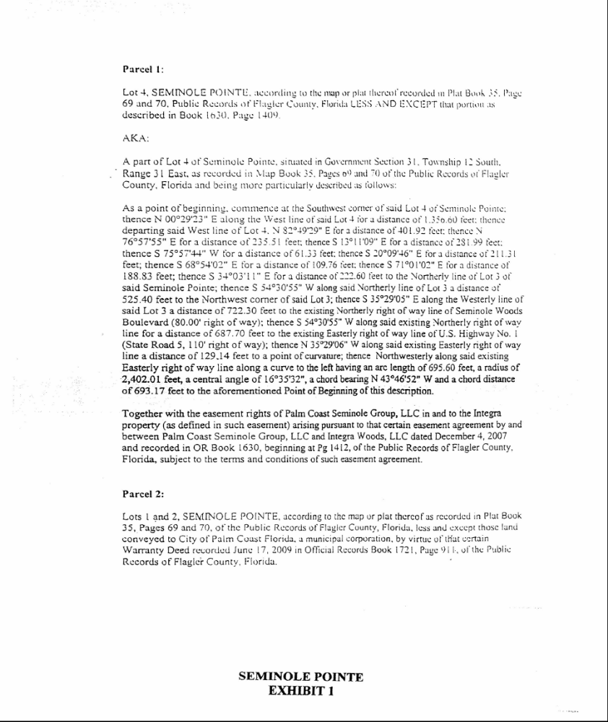

EXHIBIT 2 SEMINOLE POINTE MASTER DEVELOPMENT PLANS, MPD 1 OF 2

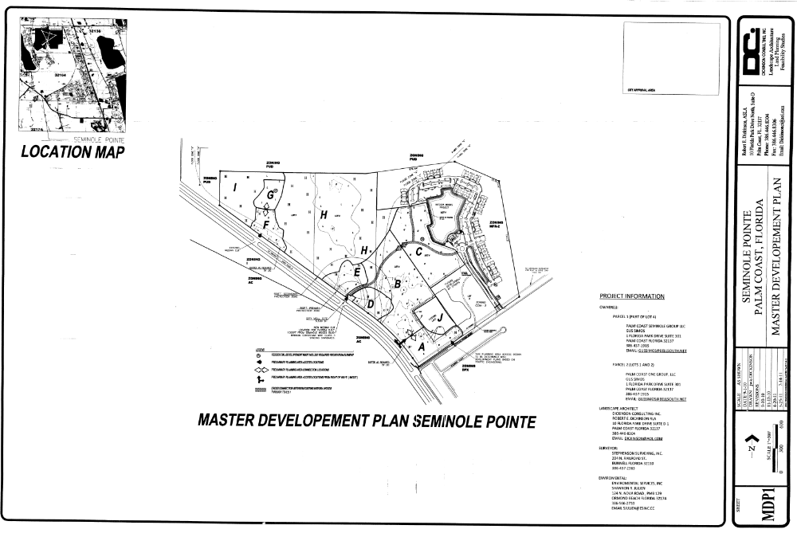

EXHIBIT 2 – SEMINOLE POINTE MASTER DEVELOPMENT PLANS MPD 2 OF 2

