Prepared by:

Continental Properties Company, Inc.
W134 N8675 Executive Parkway
Menomonee Falls, WI 53151
Attn: Legal Department

TEMPORARY CONSTRUCTION EASEMENT AGREEMENT

THIS TEMPORARY CONSTRUCTION EASEMENT AGREEMENT (the “Agreement”) is made and entered into this _____ day of, , 2008, by and between the CITY OF PALM COAST, with an address of 2 Commerce Drive, Palm Coast, Florida 32137 (the “City”) and PC PARKWAY PLAZA, LLC, a Florida limited liability company, with an address of c/o Continental Properties Company, Inc., W134 N8675 Executive Parkway, Menomonee Falls, Wisconsin 53051 (“PC”), for the benefit of property described on Exhibit A attached hereto.

WITNESSETH:

WHEREAS, the City owns certain real property situated in the City of Palm Coast, Florida more particularly described in and depicted on Exhibit “A” attached hereto and incorporated herein by reference (the “City Property”).

WHEREAS, PC owns certain real property situated in the City of Palm Coast, Florida more particularly described in and depicted on Exhibit “B” attached hereto and incorporated herein by reference (the “PC Property”).

WHEREAS, PC intends to construct and develop a retail shopping center (the “Shopping Center”) on the PC Property and the City Property as depicted on Exhibit “C” attached hereto and incorporated herein by reference (the “site plan”).

WHEREAS, pursuant to that certain City of Palm Coast and PC Parkway Investments, LLC, Real Estate Exchange Agreement dated May 15, 2007 (the “Exchange Agreement”), the City has agreed to relocate from the existing fire station located on the City Property to a new fire station to be constructed by PC on the PC Property (the “Fire Station Relocation”).

WHEREAS, in order to facilitate the timely construction and opening of the Shopping Center and the Fire Station Relocation, the City has agreed to convey to PC, its successors and assigns, for the benefit of the PC Property, certain non-exclusive easements for construction, access, ingress, egress, parking, and the maintenance of certain improvements (the “Improvements”) more particularly described in that certain Site Plan Development Order SP-MAJ-07-09 approved by the City on October 2, 2007 over that portion of the City Property more particularly described in and depicted on Exhibit “D” attached hereto and incorporated herein by reference (the “Easement Area”) which Easement Area is more particularly depicted, in context with abutting properties and improvements to those properties in Exhibit “E”..

FOR AND IN CONSIDERATION OF the sum of ONE AND NO/100 DOLLAR ($1.00) and other good and valuable consideration, the receipt and sufficiency of which are hereby acknowledged, the parties hereto agree as follows:

1. Grant of Easements by the City. The City hereby declares, establishes, creates, grants, conveys and warrants the following temporary rights, privileges and easements appurtenant to the PC Property in and to the Easement Area for PC, its agents, contractors, tenants, licensees, guests, invitees, grantees, employees, representatives, successors (including, without limitation, any and all successors to PC in title to the PC Property) and assigns:

a. A non-exclusive right and easement for the purposes of constructing the Improvements and ingress and egress for construction equipment and personnel across the Easement Area, subject to the limitations set forth in Section 2 of this Easement;

b. A non-exclusive right and easement for vehicular and pedestrian access, ingress and egress for the purpose of vehicular and pedestrian access, ingress and egress to and from the PC Property and public streets and highways abutting, adjacent to, or near the PC Property, subject to the limitations set forth in Section 2 of this Easement; and

c. A non-exclusive easement for parking and the maintenance of the Improvements (collectively, the non-exclusive rights and easements referenced in Section 1a-c above shall be referenced herein as the “Easements”).

2. Nondisturbance. Notwithstanding anything to the contrary contained herein, in exercising its rights hereunder, PC shall not interfere with the fire and emergency services operations conducted by the City of Palm Coast Fire Department on the City Property. Specifically, unless otherwise authorized by the Chief of the City of Palm Coast Fire Department, which authorization shall be granted in the Chief’s sole discretion, PC shall not i) utilize the existing access point between Belle Terre Parkway and the City Property; ii) conduct any construction staging within the Easement Area; and/or iii) utilize the existing utility service serving the City Property. Subject to the limitations set forth in this Section 2, the City shall not obstruct, disrupt or otherwise interfere with PC’s use of the Easement Area as contemplated herein.

3. Construction Liens. All persons are hereby noticed that no lien of any type or nature is permitted on the City Property or Easement Area, In the event any lien(s) are filed against the City Property, the Easement Area, or any portions thereof, in connection with any work performed by or on behalf of PC or in connection with any act or omission of PC pursuant to this Agreement, PC shall bond over or cause said liens to be immediately discharged of record.

4. Indemnity. PC shall defend, indemnify and save harmless the City, its officers, agents and employees from, against and with respect to any and all suits, demands, causes of actions, liabilities, claims, losses, costs and expenses relating to or arising from or with respect to any injury or damages of whatever nature, including death, or damage to property arising out of or related to the negligence or willful misconduct of PC, its agents, employees, licensees or contractors, their agents or employees with respect to the Easement Area.

5. Scope of Easements. The Temporary Easements set forth herein shall bind and inure to the benefit and use of the parties hereto, their successors, successors in title, tenants and assigns until such time as this Agreement is terminated by the parties in writing which is intended to occur as part of the Fire Station Relocation.

6, Maintenance. PC, at PC’s sole cost and expense, shall maintain the Easement Area in good order and repair. PC covenants and agrees to complete the Improvements to be located in the Easement Area once PC has commenced construction of such improvements in the Easement Area. The City may require PC to post a performance bond or letter of credit to ensure that the City Property and Easement Area will be adequately restored in the event that PC’s development efforts should terminate, or be suspended, provided that said surety shall be in a form and amount reasonably acceptable to the City and PC and issued by a financial institution reasonably acceptable to the City and PC. At PC’s option, it may post a cash bond with the City in lieu of other financial assurances, to be refunded to PC upon the earliler of (a) the completion of the Fire Station Relocation; or (b) the restoration of the Easement Property by (i) re-grading the property to its grade prior to the granting of this easement; and (ii) planting of vegetation of a similar kind and nature of the vegetation removed by PC. The City may draw upon such financial assurance only upon thirty (30) days prior written notice to PC and after the City has determined, in its reasonable discretion that PC has failed to perform any such restoration work in a commercially reasonable manner.

7. Effective Date. The Temporary Easements and covenants created and imposed by this Agreement shall be effective upon the execution and delivery of this instrument and shall terminate upon (i) the completion of the Fire Station Relocation, and conveyances contemplated by the Relocation Agreement or (ii) after five (5) days prior written notice to PC, the recording of an affidavit by the City Manager of the City stating that the temporary rights herein granted have terminated because PC’s activities have interfered with the fire and emergency services operations conducted by the City of Palm Coast Fire Department on the City Property . Notwithstanding the preceding sentence, except in the case of an imminent public hazard, PC shall have thirty (30) days after such five-day notice to remedy any condition causing such interference prior to any termination. The City hereby acknowledges and agrees that the site work and related activities described on Exhibit “G” attached hereto and incorporated herein shall not constitute interference with the fire and emergency service operations conducted by the City of Palm Coast Fire Department for purposes of this Section 2.

8. Governing Law/Interpretation/Venue. This Agreement shall be governed by and construed in accordance with the laws of the State of Florida and has been negotiated by the parties hereto. The parties represent and warrant to one another that each has, by counsel or otherwise, actively participated in the finalization of this Agreement, and in the event of a dispute concerning the interpretation of this Agreement, each party hereby waives the doctrine that an ambiguity should be interpreted against the party which has drafted the document. Venue shall be in the Seventh Judicial Circuit Court in and for Flagler County and the parties hereto waive their right to trial by jury.

9. Approval/Consent. Each party hereby represents to the other that all approvals and consents have been obtained authorizing the execution of this Agreement by such party.

10. Waiver and Amendment. No delay or omission by any party to this Agreement to exercise any right or power accruing upon any noncompliance or failure of performance by any other party of the terms, provisions or conditions of this Agreement shall impair any such right or power or be construed to be a waiver thereof. No amendment shall be effective unless the same shall be in writing and executed by the parties hereto, or their successors or assigns.

11. Severability. If any term, provision or condition contained in this Agreement shall, to any extent, be invalid or unenforceable, the remainder of this Agreement (or the application of such term, provision or condition to persons or circumstances other than those in respect of which it is invalid or unenforceable) shall not be affected thereby, and each term, provision or condition of this Agreement shall be valid and enforceable to the fullest extent permitted by law.

12. Counterparts. This Agreement may be executed in several counterparts, each of which shall be deemed an original, but all of which together shall constitute one and the same instrument.

IN WITNESS WHEREOF, the parties have executed this Agreement as of the day and year first above written.

 | CITY OF PALM COAST, FLORIDA
ATTEST: | Jon Netts, Mayor
Clare M. Hoeni, City Clerk

WITNESSES: PC:

PC PARKWAY PLAZA, LLC
Signature
__________________________ By:
Print Name:
Title:

Signature
__________________________
Print

ACKNOWLEDGMENTS

STATE OF FLORIDA )
) SS.
FLAGLER COUNTY )

Personally came before me this ______ day of ___________________, 20__ the above named ____________________________________, the ________________________ of the City of Palm Coast, Florida, to me known to be said and acknowledged that [s]he executed the foregoing instrument as the deed of the City of Palm Coast, Florida, by its authority.

Notary Public, Flagler County, Florida
My Commission Expires:

STATE OF WISCONSIN )
) SS.
WAUKESHA COUNTY )

Personally came before me this ____ day of ___________, 20__, the above named , of , manager of PC Parkway Plaza, LLC, to me known to be said and acknowledged that [s]he executed the foregoing instrument as the deed of said limited liability company, by its authority.

Notary Public, Waukesha County, Wisconsin
My Commission Expires:
EXHIBIT A

Legal Description/Depiction of the City Property

A PARCEL OF LAND LYING IN GOVERNMENT SECTION 13, TOWNSHIP 11 SOUTH, RANGE 30 EAST, FLAGLER COUNTY, FLORIDA, BEING MORE PARTICULARLY DESCRIBED AS FOLLOWS: AS A POINT OF REFERENCE BEING THE INTERSECTION OF THE SOUTHERLY RIGHT-OF-WAY OF THE WEST BOUND ST. JOE PARKWAY (124’ R/W) RECORDED IN OFFICIAL RECORDS BOOK 305, PAGE 184 THROUGH 217, WITH THE WESTERLY RIGHT-OF-WAY OF BELLE TERRE PARKWAY (150’ R/W) RECORDED IN THE SUBDIVISION MAP WYNNFIELD – SECTION 10 PALM COAST, MAP BOOK 7, PAGE 20, OF THE PUBLIC RECORDS OF FLAGLER COUNTY, FLORIDA, THENCE SOUTH 00° 51’ 33” EAST ALONG SAID WESTERLY RIGHT-OF-WAY A DISTANCE OF 229.63 FEET TO A POINT OF CURVATURE, THENCE 180.47 FEET ALONG SAID RIGHT-OF-WAY ALONG A CURVE TO THE LEFT (CONCAVE EASTERLY) HAVING A CENTRAL ANGLE OF 03° 20’ 45”, A RADIUS OF 3,090.57 FEET, A CHORD BEARING OF SOUTH 02° 31’ 55” EAST AND A CHORD DISTANCE OF 180.45 FEET TO THE POINT OF BEGINNING OF THIS DESCRIPTION, THENCE CONTINUING ALONG SAID WESTERLY RIGHT-OF-WAY OF BELLE TERRE PARKWAY, SOUTHERLY 276.56 FEET ALONG A CURVE TO THE LEFT (CONCAVE EASTERLY) HAVING A CENTRAL ANGLE OF 03° 07’ 38”, A RADIUS OF 3,090.57 FEET, A CHORD BEARING OF SOUTH 05° 46’ 07” EAST AND A CHORD DISTANCE OF 276.47 FEET, THENCE DEPARTING SAID RIGHT-OF-WAY AND CURVE SOUTH 89° 08’ 27” WEST A DISTANCE OF 378.46 FEET, THENCE NORTH 00° 51’ 33” WEST A DISTANCE OF 275.00 FEET, THENCE NORTH 89° 08’ 27” EAST A DISTANCE OF 350 FEET TO THE POINT OF BEGINNING.

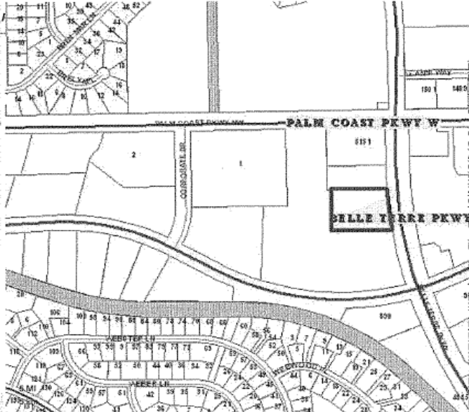

EXHIBIT B

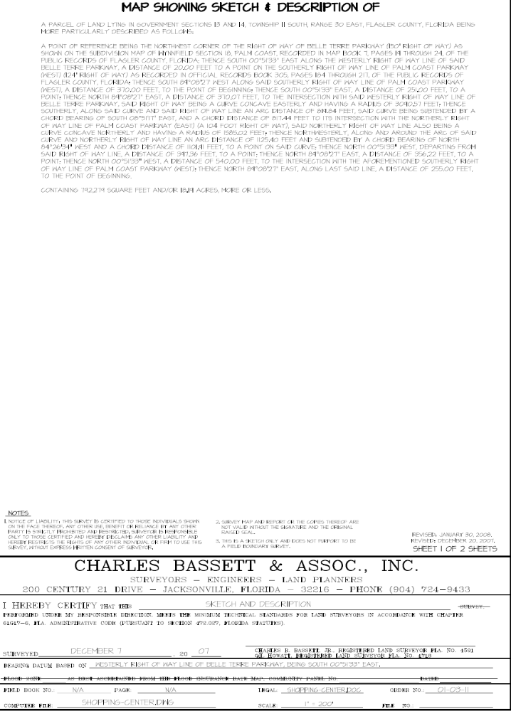

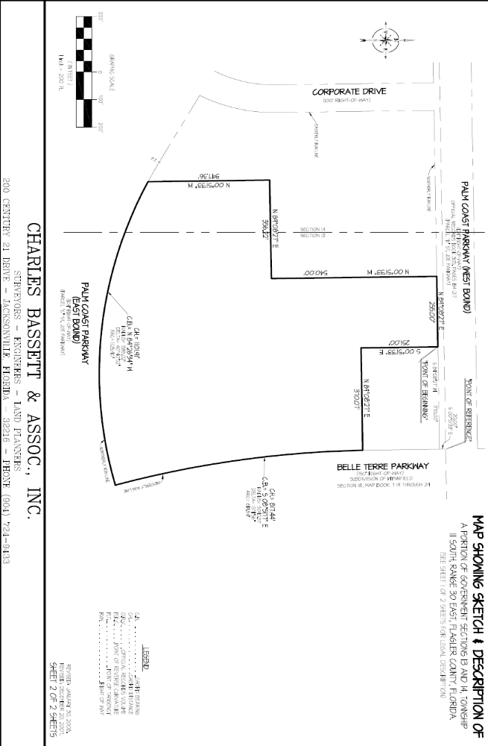

EXHIBIT C
Approved Site Plan

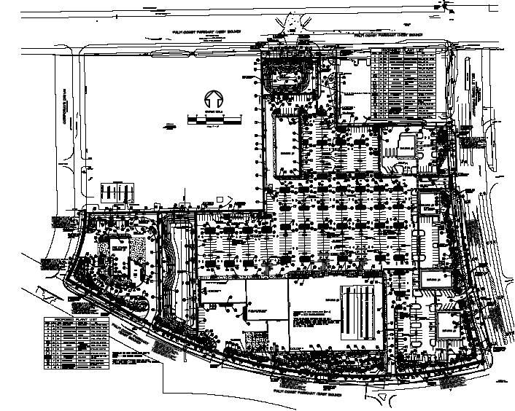

EXHIBIT D
Legal Description/Depiction of the Easement Area

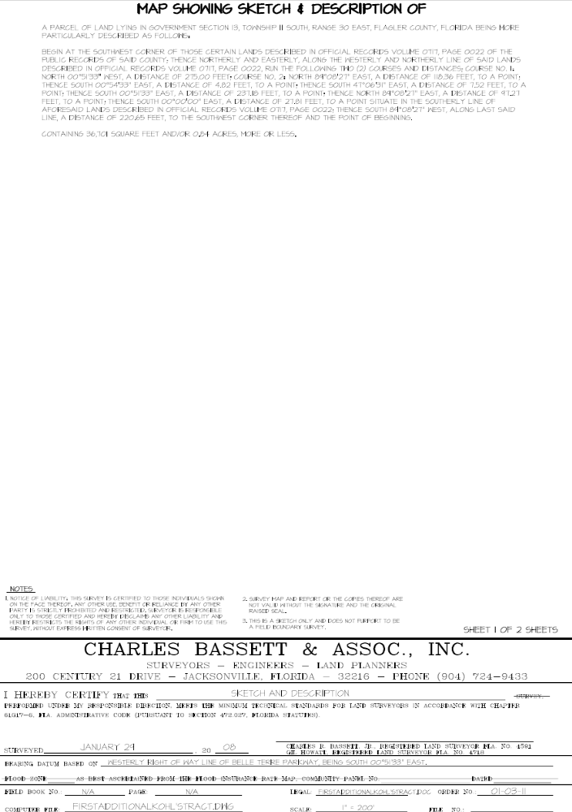

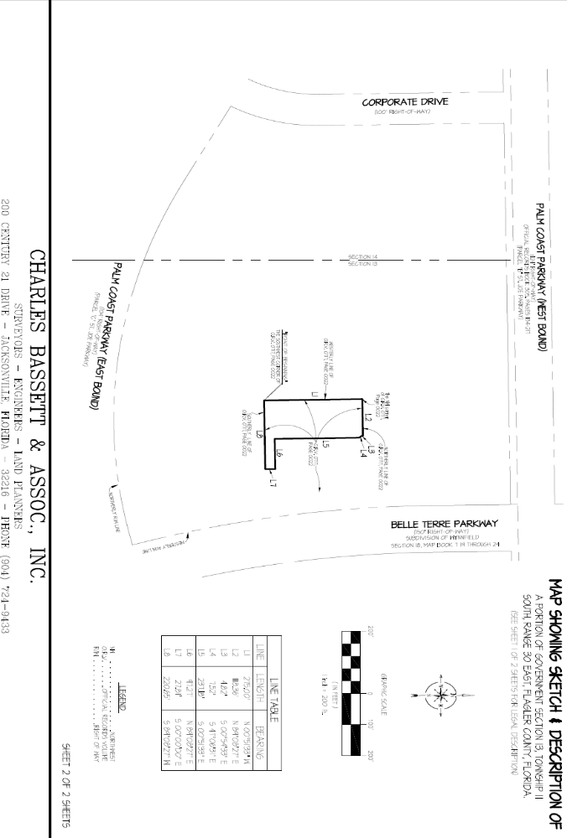

EXHIBIT E
Easement Area Depiction on Approved Site Plan

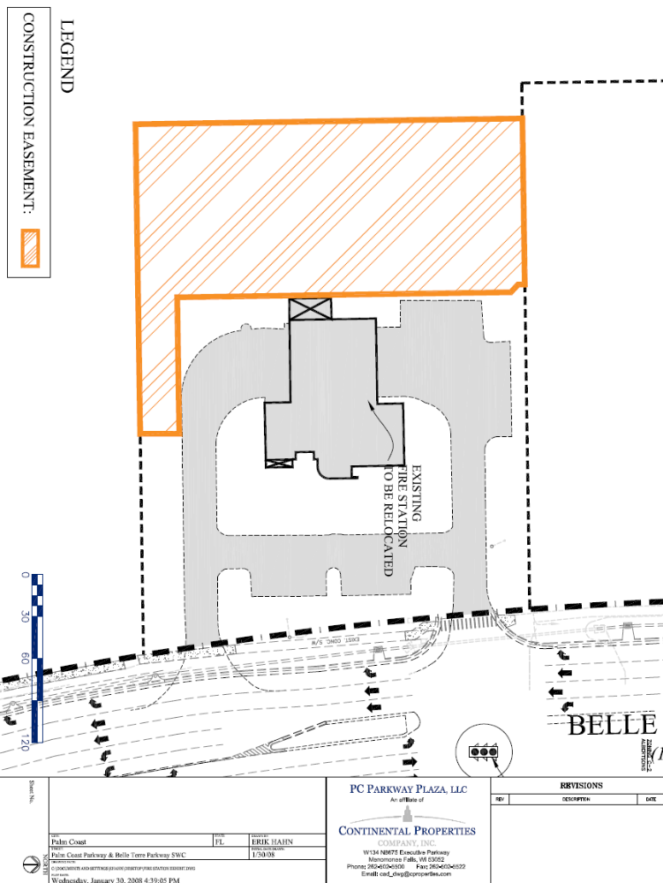
EXHIBIT F
Approved Site Work and Activities in Easement Area

All site work and activities covered by the following plans:

- Larson Binkley Parking Lot Lighting Plans dated 1/28/2008; Sheet ES 2.2 and ES 2.3
- Parker Mynchenberg & Associates, Inc. PC Parkway Plaza Final Site Plans dated 1/24/08: Sheets 5, 6, 8, 9 11, 12, 14, 15, 17, 17A, 18 and 18A, 19-29

